APPENDIX A
Fish Population Sampling Site Description
Table of Contents
Page
Middle Fork American River Downstream of Ralston Afterbay 1
MF4.8 (Peaking Reach) 1
MF14.1 (Peaking Reach) 2
MF23.5 (Peaking Reach) 3
Middle Fork American River from Middle Fork Interbay to Ralston Afterbay 4
MF26.2 (Bypass Reach) 4
Middle Fork American River from Middle Fork Interbay to Ralston Afterbay 5
MF26.2 (Bypass Reach) 5
Middle Fork American River Upstream of Middle Fork Interbay 6
MF36.2 (Bypass Reach) 6
MF44.7 (Bypass Reach) 7
MF44.7 (Bypass Reach) 8
MF51.8 (Comparison Reach above French Meadows Reservoir) 9
Rubicon River 10
R3.5 (Bypass Reach) 10
R20.9 (Bypass Reach) 11
R20.9 (Bypass Reach) 12
R25.7 (Bypass Reach) 13
R36.2 (Comparison Reach above Hell Hole Reservoir) 14
Long Canyon Creek 15
LC9.0 (Bypass Reach) 15
North Fork Long Canyon Creek 16
NFLC1.9 (Bypass Reach) 16
NFLC3.8 (Comparison Reach above North Fork Long Canyon Diversion) 17
South Fork Long Canyon Creek 18
SFLC2.3 (Bypass Reach) 18
South Fork Long Canyon Creek 19
SFLC2.3 (Bypass Reach) 19
South Fork Long Canyon Creek 20
SFLC3.0 (Bypass Reach) 20
SFLC4.2 (Comparison Reach above South Fork Long Canyon Diversion) 21
SFLC4.2 (Comparison Reach above South Fork Long Canyon Diversion) 22
SFLC5.2 (Comparison Reach above South Fork Long Canyon Diversion) 23
Duncan Creek 24
D6.3 (Bypass Reach) 24
D6.3 (Bypass Reach) 25
D8.3 (Bypass Reach) 26
D9.0 (Comparison Reach above Duncan Diversion) 27
D9.0 (Comparison Reach above Duncan Diversion) 28
D10.0 (Comparison Reach above Duncan Diversion) 29
North Fork of the Middle Fork American River 30
NFMF2.3 (Bypass Reach) 30
North Fork of the Middle Fork American River 31
NFMF2.3 (Bypass Reach) 31
North Fork American River 32
NF18.4 (Bypass Reach) 32
NF31.3 (Comparison Reach) 33
NF53.7 (Comparison Reach) 34
NF53.7 (Comparison Reach) 35
Representative Photos of Project - Reservoirs and Diversion Pools 36
Ralston Afterbay 36
Middle Fork Interbay 36
French Meadows Reservoir 37
Hell Hole Reservoir 37
North Fork Long Canyon Creek Diversion Pool 38
South Fork Long Canyon Creek Diversion Pool 38
Duncan Creek Diversion Pool 39

List of Tables

Table A-1. Reach Mesohabitat Percentages.
Table A-2. August 2007 Water Temperature Summary.
Table A-3a. 2007 Physical Habitat Characteristics of Potential Comparison Sampling Sites.
Table A-3b. 2008 Physical Habitat Characteristics of Potential Comparison Sampling Sites.
Table A-3c. 2009 Physical Habitat Characteristics of Potential Comparison Sampling Sites.

Middle Fork American River Downstream of Ralston Afterbay

MF4.8 (Peaking Reach)
2007 & 2008 Sampled Mesohabitat Units
Unit Number | Unit Type¹ | Sampling Method² | Length (ft) | Width (ft) | Unit Area (ft²) | Mean Depth (ft) | Max Depth (ft) | % of Total Survey Length | % of Total Survey Area
1 | Pool | S | 474.0 | 120.0 | 56880.0 | 5.0 | 16.0 | 12.2% | 13.0%
2 | Pool | S | 170.0 | 79.0 | 13430.0 | 4.0 | 12.0 | 4.4% | 3.1%
3 | Pool | S | 621.0 | 201.0 | 124821.0 | 4.0 | 12.0 | 16.0% | 28.5%
4 | Pool | S | 439.0 | 102.0 | 44778.0 | 9.0 | 20+ | 11.3% | 10.2%
5 | Pool | S | 756.0 | 132.0 | 99792.0 | 5.0 | 16.0 | 19.5% | 22.8%
Total |  |  | 2460.0 | -- | 339701.0 | -- | -- | 63.5% | 77.5%
Average |  |  | 492.0 | 126.8 | 67940.2 | 5.4 | 14.0 | -- | --
6 | Run | S | 190.0 | 80.0 | 15200.0 | 1.2 | 2.5 | 4.9% | 3.5%
7 | Run | S | 456.0 | 42.0 | 19152.0 | 1.0 | 2.0 | 11.8% | 4.4%
8 | Run | S | 257.0 | 129.0 | 33153.0 | 2.5 | 5.0 | 6.6% | 7.6%
9 | Run | S | 514.0 | 60.0 | 30840.0 | 2.5 | 1.5 | 13.3% | 7.0%
Total |  |  | 1417.0 | -- | 98345.0 | -- | -- | 36.5% | 22.5%
Average |  |  | 354.3 | 77.8 | 24586.3 | 1.8 | 2.8 | -- | --
Grand Total |  |  | 3877.0 | -- | 438046.0 | -- | -- | 100.0% | 100.0%
¹LGR = Low Gradient Riffle; HGR = High Gradient Riffle
²S = Snorkeling

Photos of Representative Habitat Units:
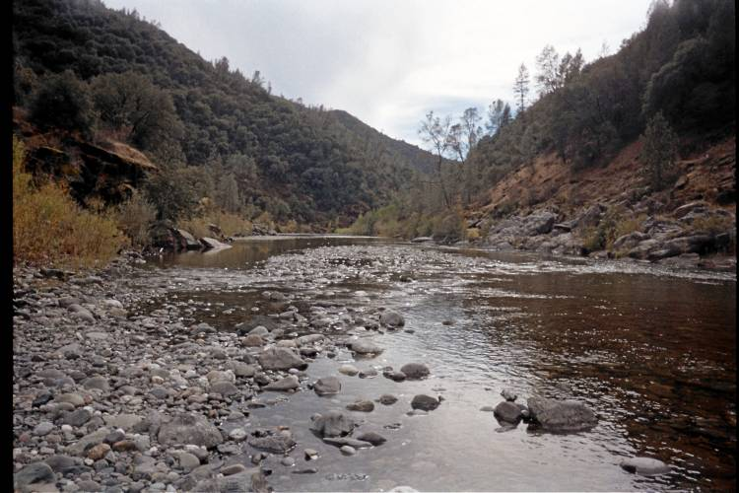 | 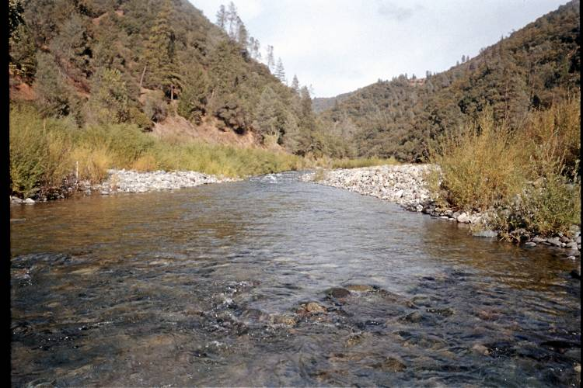
POOL | RUN

Middle Fork American River Downstream of Ralston Afterbay

MF14.1 (Peaking Reach)
2007 & 2008 Sampled Mesohabitat Units
Unit Number | Unit Type¹ | Sampling Method² | Length (ft) | Width (ft) | Unit Area (ft²) | Mean Depth (ft) | Max Depth (ft) | % of Total Survey Length | % of Total Survey Area
1 | Pool | S | 700.0 | 115.0 | 80500.0 | 2.5 | 7.0 | 20.7% | 22.2%
2 | Pool | S | 581.0 | 130.0 | 75530.0 | 3.0 | 15.0 | 17.2% | 20.8%
3 | Pool | S | 573.0 | 110.0 | 63030.0 | 9.0 | 9.0 | 17.0% | 17.4%
4 | Pool | S | 303.0 | 74.0 | 22422.0 | 3.0 | 6.5 | 9.0% | 6.2%
Total |  |  | 2157.0 | -- | 241482.0 | -- | -- | 63.9% | 66.6%
Average |  |  | 539.3 | 107.3 | 60370.5 | 4.4 | 9.4 | -- | --
5 | Run | S | 564.0 | 85.0 | 47940.0 | 1.5 | 3.0 | 16.7% | 13.2%
6 | Run | S | 520.0 | 125.0 | 65000.0 | 1.0 | 2.0 | 15.4% | 17.9%
Total |  |  | 1084.0 | -- | 112940.0 | -- | -- | 32.1% | 31.1%
Average |  |  | 542.0 | 105.0 | 56470.0 | 1.3 | 2.5 | -- | --
7 | LGR | S | 133.0 | 63.0 | 8379.0 | 0.8 | 1.3 | 3.9% | 2.3%
Total |  |  | 133.0 | -- | 8379.0 | -- | -- | 3.9% | 2.3%
Grand Total |  |  | 3374.0 | -- | 362801.0 | -- | -- | 100.0% | 100.0%
¹LGR = Low Gradient Riffle; HGR = High Gradient Riffle
²S = Snorkeling

Photos of Representative Habitat Units:
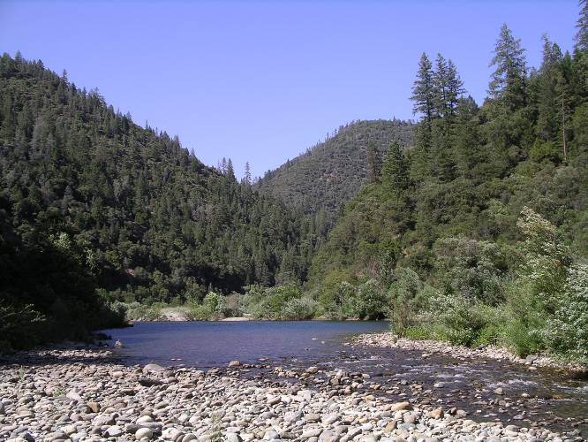 | 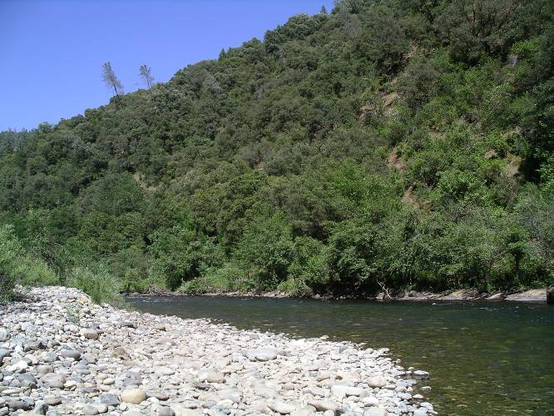
POOL | RUN
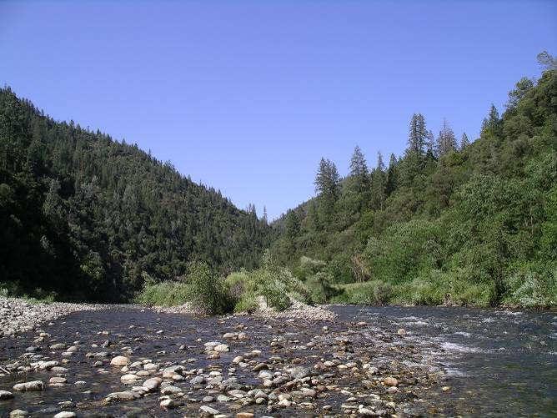
LGR

Middle Fork American River Downstream of Ralston Afterbay

MF23.5 (Peaking Reach)
2008 Sampled Mesohabitat Units
Unit Number | Unit Type¹ | Sampling Method² | Length (ft) | Width (ft) | Unit Area (ft²) | Mean Depth (ft) | Max Depth (ft) | % of Total Survey Length | % of Total Survey Area
1 | Pool | S | 477 | 105 | 50085 | 8 | 25 | 15.9% | 17.8%
2 | Pool | S | 387 | 75 | 29025 | 2.5 | 4 | 12.9% | 10.3%
3 | Pool | S | 438 | 90 | 39420 | 4.5 | 8 | 14.6% | 14.0%
4 | Pool | S | 780 | 120 | 93600 | 4 | 15 | 26.0% | 33.2%
Total |  |  | 2082 | -- | 212130 | -- | -- | 69.3% | 75.3%
Average |  |  | 520.5 | 97.5 | 53032.5 | 4.75 | 13 | -- | --
5 | Run | S | 120 | 70.5 | 8460 | 4 | 4 | 4.0% | 3.0%
6 | Run | S | 246 | 69 | 16974 | 6 | 6 | 8.2% | 6.0%
7 | Run | S | 210 | 60 | 12600 | 3.5 | 3.5 | 7.0% | 4.5%
Total |  |  | 576 | -- | 38034 | -- | -- | 19.2% | 13.5%
Average |  |  | 192 | 66.5 | 12678 | 4.5 | 4.5 | -- | --
8 | LGR | S | 126 | 150 | 18900 | 0.75 | 2 | 4.2% | 6.7%
9 | LGR | S | 105 | 45 | 4725 | 1.5 | 3 | 3.5% | 1.7%
Total |  |  | 231 | -- | 23625 | -- | -- | 7.7% | 8.4%
Average |  |  | 115.5 | 97.5 | 11812.5 | 1.125 | 2.5 | -- | --
10 | HGR | S | 114 | 70.5 | 8037 | 1.5 | 3 | 3.8% | 2.9%
Total |  |  | 114 | -- | 8037 | -- | -- | 3.8% | 2.9%
Grand Total |  |  | 3003 | -- | 281826 | -- | -- | 100% | 100%
¹LGR = Low Gradient Riffle; HGR = High Gradient Riffle
²S = Snorkeling
Photos of Representative Habitat Units:
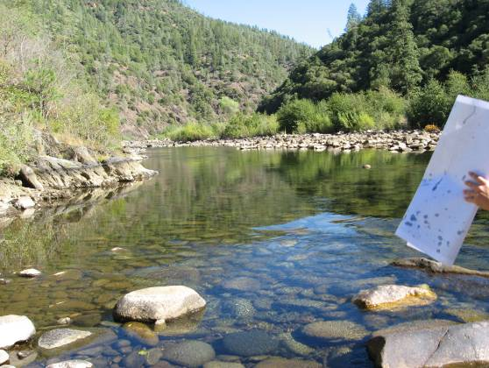 | 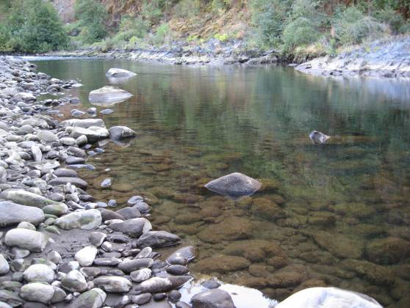
POOL | RUN
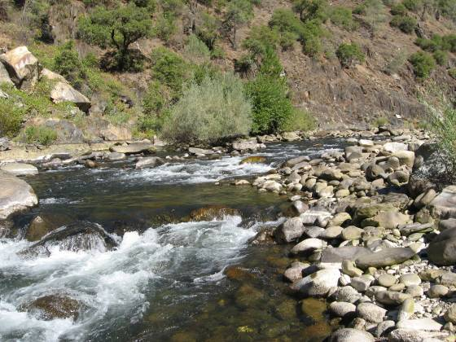 | 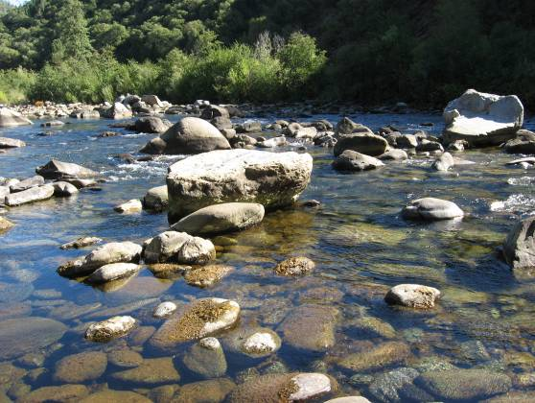
HGR | LGR

Middle Fork American River from Middle Fork Interbay to Ralston Afterbay

MF26.2 (Bypass Reach)
2007 Sampled Mesohabitat Units
Unit Number | Unit Type¹ | Sampling Method² | Length (ft) | Width (ft) | Unit Area (ft²) | Mean Depth (ft) | Max Depth (ft) | % of Total Survey Length | % of Total Survey Area
1 | Pool | S | 232.0 | 51.0 | 11832.0 | 2.8 | 5.5 | 23.9% | 26.2%
2 | Pool | S | 125.0 | 54.0 | 6750.0 | 4.5 | 7.5 | 12.9% | 14.9%
3 | Pool | S | 172.0 | 45.0 | 7740.0 | 3.0 | 12.0 | 17.7% | 17.1%
4 | Pool | S | 140.0 | 45.0 | 6300.0 | 2.6 | 5.0 | 14.4% | 13.9%
Total |  |  | 669.0 | -- | 32622.0 | -- | -- | 68.9% | 72.1%
Average |  |  | 167.3 | 48.8 | 8155.5 | 3.2 | 7.5 | -- | --
5 | Run | E | 57.0 | 43.0 | 2451.0 | 1.2 | 2.6 | 5.9% | 5.4%
6 | Run | E | 96.0 | 35.0 | 3360.0 | 1.6 | 2.6 | 9.9% | 7.4%
Total |  |  | 153.0 | -- | 5811.0 | -- | -- | 15.8% | 12.8%
Average |  |  | 76.5 | 39.0 | 2905.5 | 1.4 | 2.6 | -- | --
7 | HGR | E | 99.0 | 45.0 | 4455.0 | 1.0 | 1.8 | 10.2% | 9.8%
Total |  |  | 99.0 | -- | 4455.0 | -- | -- | 10.2% | 9.8%
8 | LGR | E | 50.0 | 47.0 | 2350.0 | 0.8 | 1.7 | 5.1% | 5.2%
Total |  |  | 50.0 | -- | 2350.0 | -- | -- | 5.1% | 5.2%
Grand Total |  |  | 971.0 | -- | 45238.0 | -- | -- | 100.0% | 100.0%
¹LGR = Low Gradient Riffle; HGR = High Gradient Riffle
²S = Snorkeling; E = Electrofishing

2008 Sampled Mesohabitat Units
Unit Number | Unit Type¹ | Sampling Method² | Length (ft) | Width (ft) | Unit Area (ft²) | Mean Depth (ft) | Max Depth (ft) | % of Total Survey Length | % of Total Survey Area
1 | Pool | S | 232.0 | 51.0 | 11832.0 | 2.8 | 5.5 | 23.7% | 26.2%
2 | Pool | S | 125.0 | 54.0 | 6750.0 | 4.5 | 7.5 | 12.8% | 15.0%
3 | Pool | S | 172.0 | 45.0 | 7740.0 | 3 | 12 | 17.6% | 17.1%
4 | Pool | S | 140.0 | 45.0 | 6300.0 | 2.6 | 5 | 14.3% | 14.0%
Total |  |  | 669.0 | -- | 32622.0 | -- | -- | 68.3% | 72.3%
Average |  |  | 167.3 | 48.8 | 8155.5 | 3.225 | 7.5
5 | Run | E | 60.0 | 36.0 | 2160.0 | 1.5 | 2.3 | 6.1% | 4.8%
6 | Run | E | 101.0 | 45.0 | 4545.0 | 0.6 | 2.5 | 10.3% | 10.1%
Total |  |  | 161.0 | 81.0 | 6705.0 | 2.1 | 4.8 | 16.4% | 14.9%
Average |  |  | 80.5 | 40.5 | 3352.5 | 1.05 | 2.4
7 | HGR | E | 99.0 | 37.0 | 3663.0 | 0.9 | 1.6 | 10.1% | 8.1%
Total |  |  | 99.0 |  | 3663.0 |  |  | 10.1% | 8.1%
8 | LGR | E | 51.0 | 42.0 | 2142.0 | 0.8 | 2 | 5.2% | 4.7%
Total |  |  | 51.0 |  | 2142.0 |  |  | 5.2% | 4.7%
Grand Total |  |  | 980.0 |  | 45132.0 |  |  | 100.0% | 100.0%
¹LGR = Low Gradient Riffle; HGR = High Gradient Riffle
²S = Snorkeling; E = Electrofishing

Middle Fork American River from Middle Fork Interbay to Ralston Afterbay

MF26.2 (Bypass Reach)

Photos of Representative Habitat Units:
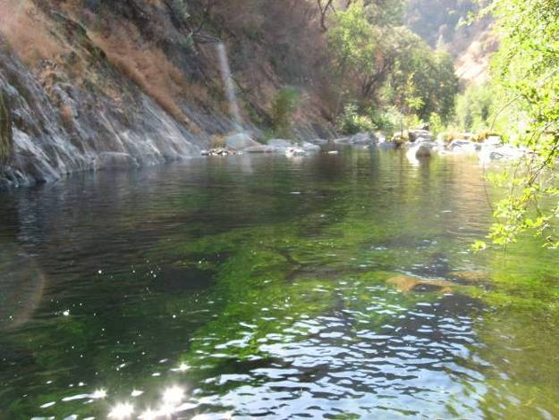 | 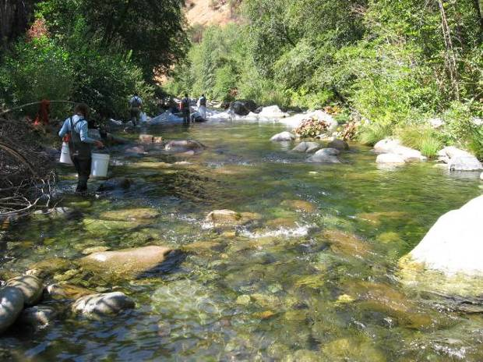
POOL | RUN
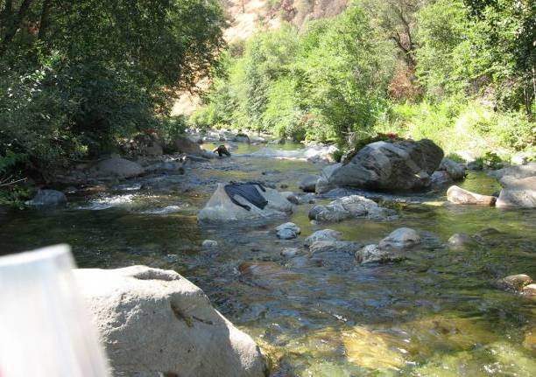 | 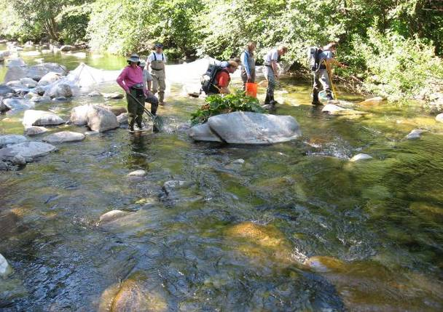
HGR | LGR

Middle Fork American River Upstream of Middle Fork Interbay

MF36.2 (Bypass Reach)
2007 Sampled Mesohabitat Units
Unit Number | Unit Type¹ | Sampling Method² | Length (ft) | Width (ft) | Unit Area (ft²) | Mean Depth (ft) | Max Depth (ft) | % of Total Survey Length | % of Total Survey Area
1 | Pool | S | 87.0 | 40.0 | 3480.0 | 2.0 | 3.5 | 16.3% | 20.2%
2 | Pool | S | 80.0 | 30.0 | 2400.0 | 3.5 | 6.0 | 15.0% | 14.0%
3 | Pool | S | 163.0 | 34.0 | 5542.0 | 1.7 | 4.5 | 30.5% | 32.2%
Total |  |  | 330.0 | -- | 11422.0 | -- | -- | 61.8% | 66.4%
Average |  |  | 110.0 | 34.7 | 3807.3 | 2.4 | 4.7 | -- | --
4 | Run | E | 40.0 | 30.0 | 1200.0 | 2.1 | 2.8 | 7.5% | 7.0%
5 | Run | E | 60.0 | 26.0 | 1560.0 | 1.4 | 4.1 | 11.2% | 9.1%
Total |  |  | 100.0 | -- | 2760.0 | -- | -- | 18.7% | 16.0%
Average |  |  | 50.0 | 28.0 | 1380.0 | 1.8 | 3.5 | -- | --
6 | HGR | E | 104.0 | 29.0 | 3016.0 | 1.4 | 2.1 | 19.5% | 17.5%
Total |  |  | 104.0 | -- | 3016.0 | -- | -- | 19.5% | 17.5%
Grand Total |  |  | 534.0 | -- | 17198.0 | -- | -- | 100.0% | 100.0%
¹LGR = Low Gradient Riffle; HGR = High Gradient Riffle
²S = Snorkeling; E = Electrofishing

Photos of Representative Habitat Units:
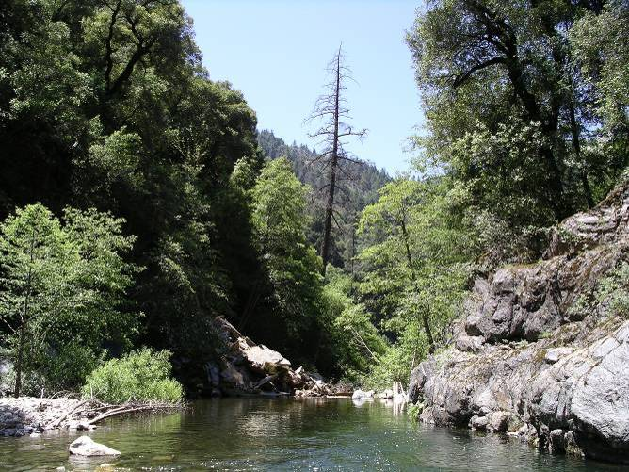 | 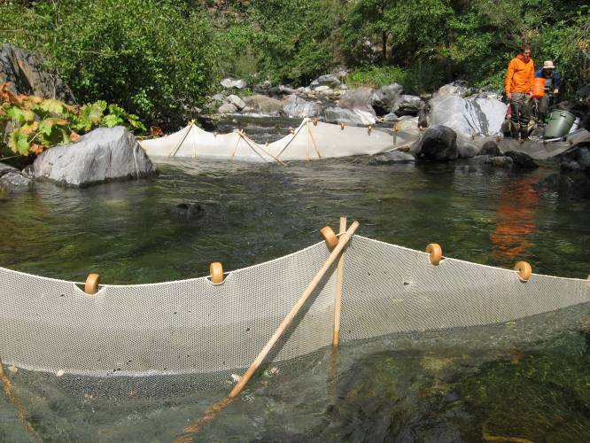
POOL | RUN
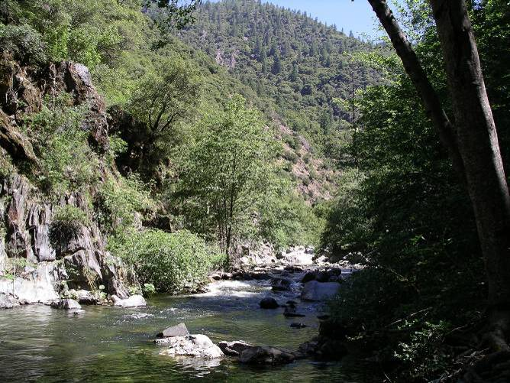
HGR

Middle Fork American River Upstream of Middle Fork Interbay

MF44.7 (Bypass Reach)
2007 Sampled Mesohabitat Units
Unit Number | Unit Type¹ | Sampling Method² | Length (ft) | Width (ft) | Unit Area (ft²) | Mean Depth (ft) | Max Depth (ft) | % of Total Survey Length | % of Total Survey Area
1 | Pool | S | 141.0 | 39.0 | 5499.0 | 3.0 | 4.6 | 19.9% | 21.1%
2 | Pool | S | 132.0 | 45.0 | 5940.0 | 2.6 | 4.2 | 18.6% | 22.8%
3 | Pool | S | 215.0 | 35.0 | 7525.0 | 2.3 | 3.8 | 30.3% | 28.9%
Total |  |  | 488.0 | -- | 18964.0 | -- | -- | 68.7% | 72.8%
Average |  |  | 162.7 | 39.7 | 6321.3 | 2.6 | 4.2 | -- | --
4 | Run | E | 92.0 | 31.0 | 2852.0 | 1.6 | 3.5 | 13.0% | 10.9%
Total |  |  | 92.0 | -- | 2852.0 | -- | -- | 13.0% | 10.9%
5 | HGR | E | 80.0 | 36.0 | 2880.0 | 1.2 | 3.6 | 11.3% | 11.1%
6 | HGR | E | 50.0 | 27.0 | 1350.0 | 1.8 | 3.0 | 7.0% | 5.2%
Total |  |  | 130.0 | -- | 4230.0 | -- | -- | 18.3% | 16.2%
Average |  |  | 65.0 | 31.5 | 2115.0 | 1.5 | 3.3 | -- | --
Grand Total |  |  | 710.0 | -- | 26046.0 | -- | -- | 100.0% | 100.0%
¹ LGR = Low Gradient Riffle; HGR = High Gradient Riffle
²S = Snorkeling; E = Electrofishing

2008 Sampled Mesohabitat Units
Unit Number | Unit Type¹ | Sampling Method² | Length (ft) | Width (ft) | Unit Area (ft²) | Mean Depth (ft) | Max Depth (ft) | % of Total Survey Length | % of Total Survey Area
1 | Pool | S | 143.0 | 30.0 | 4290.0 | 2.5 | 4.0 | 22.8% | 26.0%
2 | Pool | S | 127.5 | 30.0 | 3825.0 | 2.5 | 5.0 | 20.3% | 23.2%
3 | Pool | S | 120.0 | 25.0 | 3000.0 | 2.0 | 3.5 | 19.1% | 18.2%
Total |  |  | 390.5 | -- | 11115.0 | -- | -- | 62.1% | 67.3%
Average |  |  | 130.2 | 28.3 | 3705.0 | 2.3 | 4.2 | -- | --
4 | Run | E | 101.0 | 24.0 | 2424.0 | 1.7 | 3.4 | 16.1% | 14.7%
Total |  |  | 101.0 | -- | 2424.0 | -- | -- | 16.1% | 14.7%
5 | HGR | E | 87.0 | 25.0 | 2175.0 | 1.5 | 4.0 | 13.8% | 13.2%
6 | HGR | E | 50.0 | 16.0 | 800.0 | 1.5 | 2.7 | 8.0% | 4.8%
Total |  |  | 137.0 | -- | 2975.0 | -- | -- | 21.8% | 18.0%
Average |  |  | 68.5 | 20.5 | 1487.5 | 1.5 | 3.4 | -- | --
Grand Total |  |  | 628.5 | -- | 16514.0 | -- | -- | 100.0% | 100.0%

Middle Fork American River Upstream of Middle Fork Interbay

MF44.7 (Bypass Reach)

Photos of Representative Habitat Units:
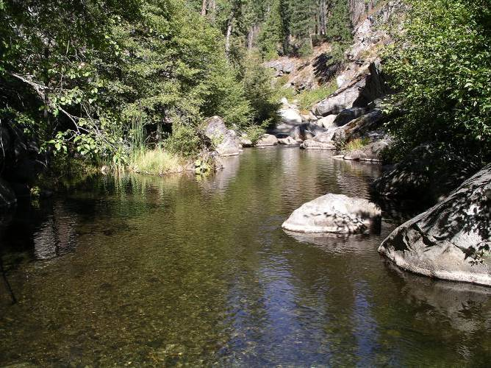 | 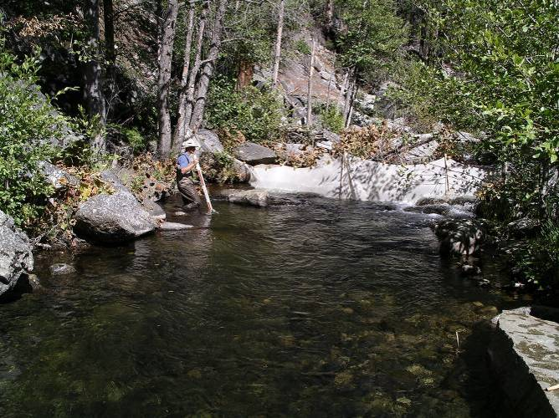
POOL | Run
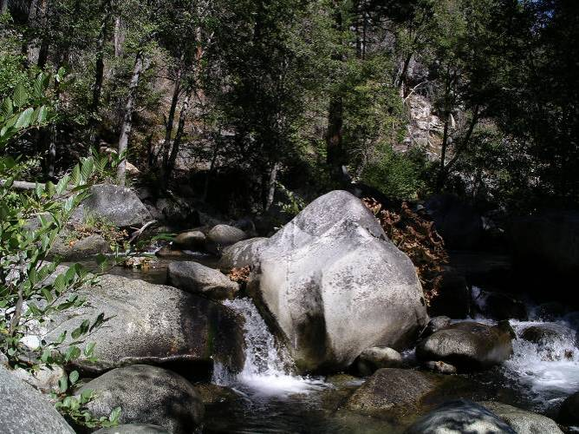
HGR

Middle Fork American River Upstream of Middle Fork Interbay

MF51.8 (Comparison Reach above French Meadows Reservoir)
2007 Sampled Mesohabitat Units
Unit Number | Unit Type¹ | Sampling Method² | Length (ft) | Width (ft) | Unit Area (ft²) | Mean Depth (ft) | Max Depth (ft) | % of Total Survey Length | % of Total Survey Area
1 | Pool | E | 158.0 | 44.0 | 6952.0 | 1.3 | 2.5 | 23.9% | 24.4%
2 | Pool | E | 120.0 | 39.0 | 4680.0 | 1.5 | 3.1 | 18.2% | 16.4%
3 | Pool | E | 75.0 | 36.0 | 2700.0 | 1.4 | 2.5 | 11.4% | 9.5%
Total |  |  | 353.0 | -- | 14332.0 | -- | -- | 53.5% | 50.2%
Average |  |  | 117.7 | 39.7 | 4777.3 | 1.4 | 2.7 | -- | --
4 | Run | E | 105.0 | 42.0 | 4410.0 | 0.7 | 1.5 | 15.9% | 15.4%
5 | Run | E | 82.0 | 42.0 | 3444.0 | 0.4 | 1.4 | 12.4% | 12.1%
Total |  |  | 187.0 | -- | 7854.0 | -- | -- | 28.3% | 27.5%
Average |  |  | 93.5 | 42.0 | 3927.0 | 0.6 | 1.5 | -- | --
6 | LGR | E | 120.0 | 53.0 | 6360.0 | 0.4 | 1.4 | 18.2% | 22.3%
Total |  |  | 213.5 | -- | 10287.0 | -- | -- | 32.3% | 36.0%
Grand Total |  |  | 660.0 | -- | 28546.0 | -- | -- | 100.0% | 100.0%
¹LGR = Low Gradient Riffle; HGR = High Gradient Riffle
²E = Electrofishing

Photos of Representative Habitat Units:
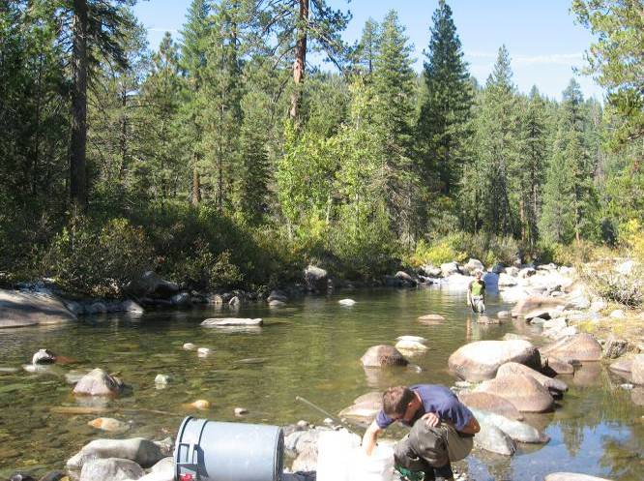 | 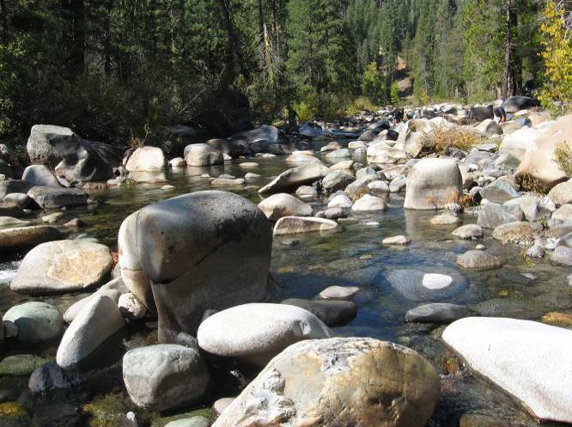
POOL | RUN
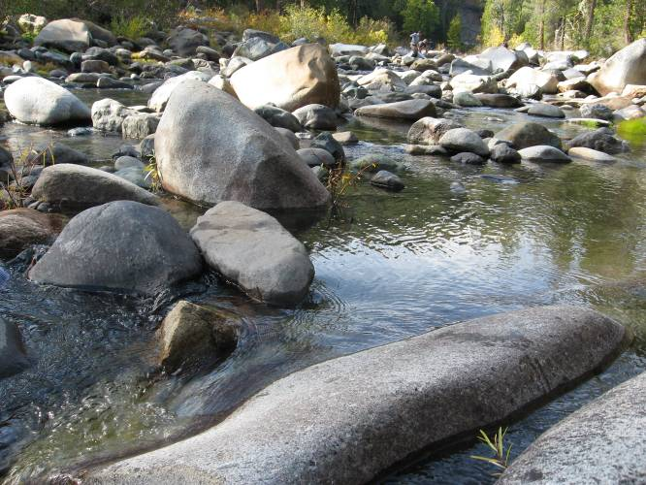
LGR

Rubicon River

R3.5 (Bypass Reach)
2007 Sampled Mesohabitat Units
Unit Number | Unit Type¹ | Sampling Method² | Length (ft) | Width (ft) | Unit Area (ft²) | Mean Depth (ft) | Max Depth (ft) | % of Total Survey Length | % of Total Survey Area
1 | Pool | S | 150.0 | 55.0 | 8250.0 | * | * | 10.5% | 9.5%
2 | Pool | S | 423.0 | 65.0 | 27495.0 | 2.5 | 12.0 | 29.6% | 31.7%
3 | Pool | S | 105.0 | 48.0 | 5040.0 | 2.0 | 4.5 | 7.4% | 5.8%
4 | Pool | S | 365.0 | 55.0 | 20075.0 | 4.5 | 14.0 | 25.6% | 23.2%
Total |  |  | 1043.0 | -- | 60860.0 | -- | -- | 73.1% | 70.2%
Average |  |  | 260.8 | 55.8 | 15215.0 | 3.0 | 10.2 | -- | --
5 | Run | S | 132.0 | 75.0 | 9900.0 | * | * | 9.3% | 11.4%
6 | Run | E | 96.0 | 63.0 | 6048.0 | 1.5 | 3.2 | 6.7% | 7.0%
Total |  |  | 228.0 | -- | 15948.0 | -- | -- | 16.0% | 18.4%
Average |  |  | 114.0 | 69.0 | 7974.0 | 1.5 | 3.2 | -- | --
7 | HGR | E | 81.0 | 63.0 | 5103.0 | 1.4 | 3.1 | 5.7% | 5.9%
Total |  |  | 81.0 | -- | 5103.0 | -- | -- | 5.7% | 5.9%
8 | LGR | E | 75.0 | 63.0 | 4725.0 | 1.0 | 2.2 | 5.3% | 5.5%
Total |  |  | 75.0 | -- | 4725.0 | -- | -- | 5.3% | 5.5%
Grand Total |  |  | 1427.0 | -- | 86636.0 | -- | -- | 100% | 100%
¹LGR = Low Gradient Riffle; HGR = High Gradient Riffle
²S = Snorkeling; E = Electrofishing

Photos of Representative Habitat Units:
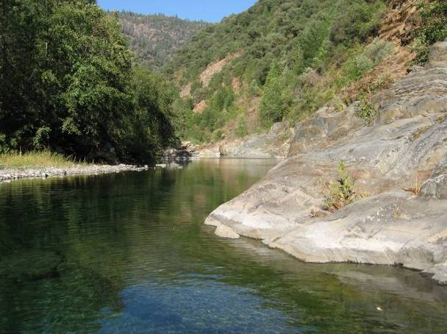 | 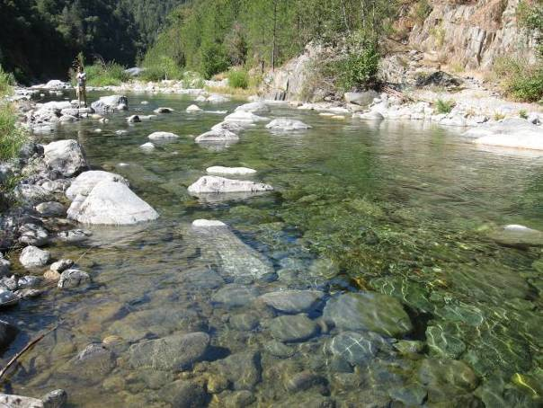
POOL | RUN
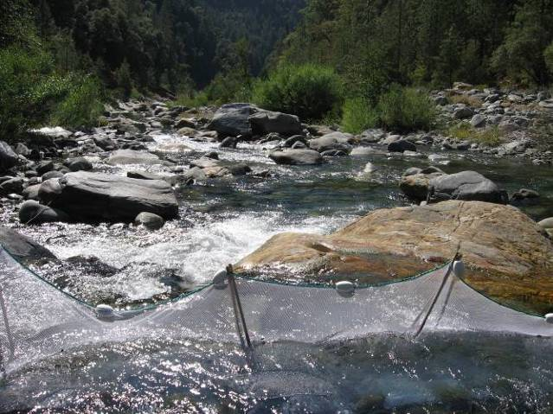 | 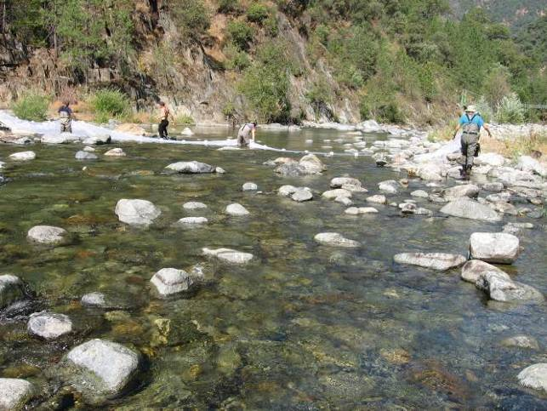
HGR | LGR
Rubicon River

R20.9 (Bypass Reach)
2007 Sampled Mesohabitat Units
Unit Number | Unit Type¹ | Sampling Method² | Length (ft) | Width (ft) | Unit Area (ft²) | Mean Depth (ft) | Max Depth (ft) | % of Total Survey Length | % of Total Survey Area
1 | Pool | S | 315.0 | 70.0 | 22050.0 | * | 18.0 | 25.7% | 30.0%
2 | Pool | S | 45.0 | 90.0 | 4050.0 | * | 5.0 | 3.7% | 5.5%
3 | Pool | S | 300.0 | 60.0 | 18000.0 | 2.5 | 5.0 | 24.5% | 24.5%
4 | Pool | S | 195.0 | 66.0 | 12870.0 | 6.0 | 12.0 | 15.9% | 17.5%
Total |  |  | 855.0 | -- | 56970.0 | -- | -- | 69.9% | 77.5%
Average |  |  | 213.8 | 71.5 | 14242.5 | 4.3 | 10.0 | -- | --
5 | Run | E | 93.0 | 36.0 | 3348.0 | 1.6 | 3.7 | 7.6% | 4.6%
6 | Run | S | 165.0 | 55.0 | 9075.0 | * | 3.0 | 13.5% | 12.3%
Total |  |  | 258.0 | -- | 12423.0 | -- | -- | 21.1% | 16.9%
Average |  |  | 129.0 | 45.5 | 6211.5 | 1.6 | 3.4 | -- | --
7 | HGR | E | 111.0 | 37.0 | 4107.0 | 1.7 | 4.0 | 9.1% | 5.6%
Total |  |  | 111.0 | -- | 4107.0 | -- | -- | 9.1% | 5.6%
Grand Total |  |  | 1224.0 | -- | 73500.0 | -- | -- | 100.0% | 100.0%
¹LGR = Low Gradient Riffle; HGR = High Gradient Riffle
²S = Snorkeling; E = Electrofishing
2008 Sampled Mesohabitat Units
Unit Number | Unit Type¹ | Sampling Method² | Length (ft) | Width (ft) | Unit Area (ft²) | Mean Depth (ft) | Max Depth (ft) | % of Total Survey Length | % of Total Survey Area
1 | Pool | S | 315.0 | 70.0 | 22050.0 | * | 18.0 | 25.4% | 29.5%
2 | Pool | S | 45.0 | 90.0 | 4050.0 | * | 5.0 | 3.6% | 5.4%
3 | Pool | S | 300.0 | 60.0 | 18000.0 | 2.5 | 5.0 | 24.2% | 24.1%
4 | Pool | S | 195.0 | 66.0 | 12870.0 | 6.0 | 12.0 | 15.7% | 17.2%
Total |  |  | 855.0 | -- | 56970.0 | -- | -- | 69.0% | 76.3%
Average |  |  | 213.8 | 71.5 | 14242.5 | 4.3 | 10.0 | -- | --
5 | Run | E | 109.0 | 30.0 | 3270.0 | 1.4 | 3.4 | 8.8% | 4.4%
6 | Run | S | 165.0 | 55.0 | 9075.0 | * | 3.0 | 13.3% | 12.2%
Total |  |  | 274.0 | -- | 12345.0 | -- | -- | 22.1% | 16.5%
Average |  |  | 137.0 | 42.5 | 6172.5 | 1.4 | 3.2 | -- | --
7 | HGR | E | 111.0 | 48.0 | 5328.0 | 1.9 | 3.5 | 9.0% | 7.1%
Total |  |  | 111.0 | -- | 5328.0 | -- | -- | 9.0% | 7.1%
Grand Total |  |  | 1240.0 | -- | 74643.0 | -- | -- | 100.0% | 100.0%
¹LGR = Low Gradient Riffle; HGR = High Gradient Riffle
²S = Snorkeling; E = Electrofishing

Rubicon River

R20.9 (Bypass Reach)

Photos of Representative Habitat Units:
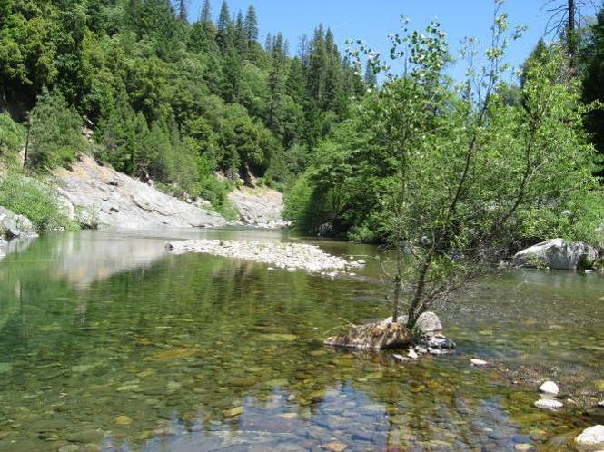 | 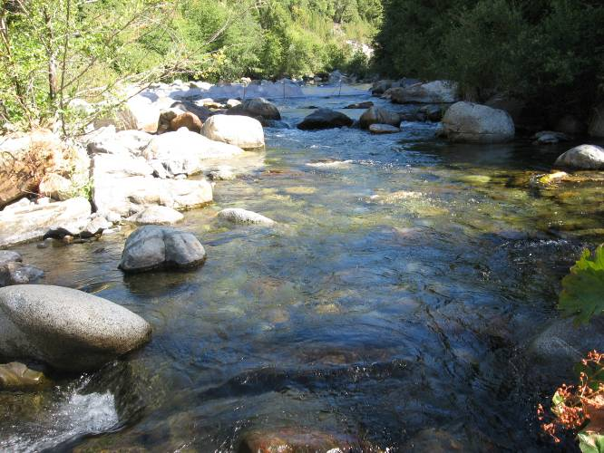
POOL | RUN
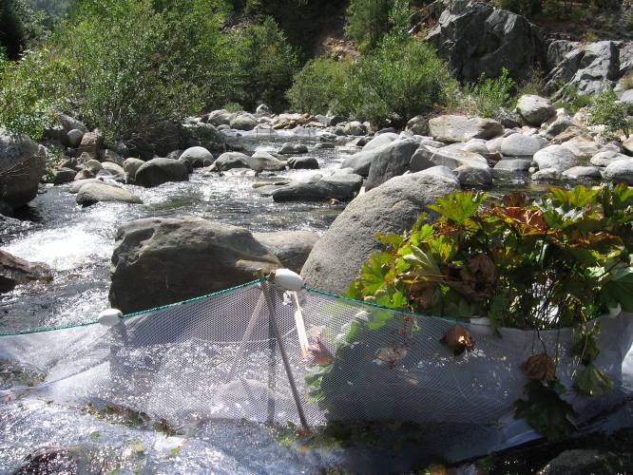
HGR

Rubicon River

R25.7 (Bypass Reach)
2007 Sampled Mesohabitat Units
Unit Number | Unit Type¹ | Sampling Method² | Length (ft) | Width (ft) | Unit Area (ft²) | Mean Depth (ft) | Max Depth (ft) | % of Total Survey Length | % of Total Survey Area
1 | Pool | S | 60.0 | 237.0 | 14220.0 | 2.0 | 8.0 | 14.5% | 41.3%
2 | Pool | S | 33.0 | 216.0 | 7128.0 | 2.0 | 5.5 | 8.0% | 20.7%
3 | Pool | S | 52.0 | 54.0 | 2808.0 | 3.5 | 6.0 | 12.6% | 8.2%
Total |  |  | 145.0 | -- | 24156.0 | -- | -- | 35.1% | 70.2%
Average |  |  | 48.3 | 169.0 | 8052.0 | 2.5 | 6.5 | -- | --
4 | Run | E | 75.0 | 29.0 | 2175.0 | 1.8 | 3.1 | 18.2% | 6.3%
5 | Run | E | 69.0 | 45.0 | 3105.0 | 1.3 | 2.4 | 16.7% | 9.0%
Total |  |  | 144.0 | -- | 5280.0 | -- | -- | 34.9% | 15.4%
Average |  |  | 72.0 | 37.0 | 2640.0 | 1.6 | 2.8 | -- | --
6 | HGR | E | 62.0 | 39.0 | 2418.0 | 1.0 | 2.1 | 15.0% | 7.0%
Total |  |  | 62.0 | -- | 2418.0 | -- | -- | 15.0% | 7.0%
7 | LGR | E | 62.0 | 41.0 | 2542.0 | 0.8 | 2.5 | 15.0% | 7.4%
Total |  |  | 62.0 | -- | 2542.0 | -- | -- | 15.0% | 7.4%
Grand Total |  |  | 413.0 | -- | 34396.0 | -- | -- | 100.0% | 100.0%
¹LGR = Low Gradient Riffle; HGR = High Gradient Riffle
²S = Snorkeling; E = Electrofishing
Photos of Representative Habitat Units:
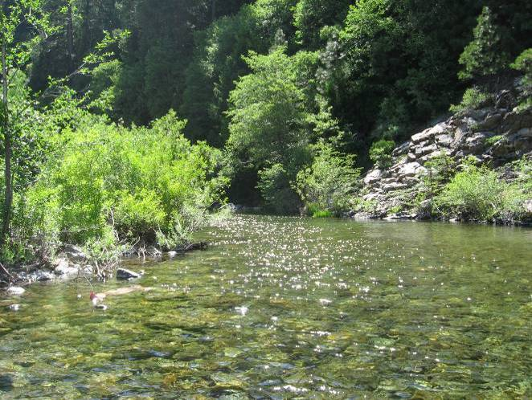 | 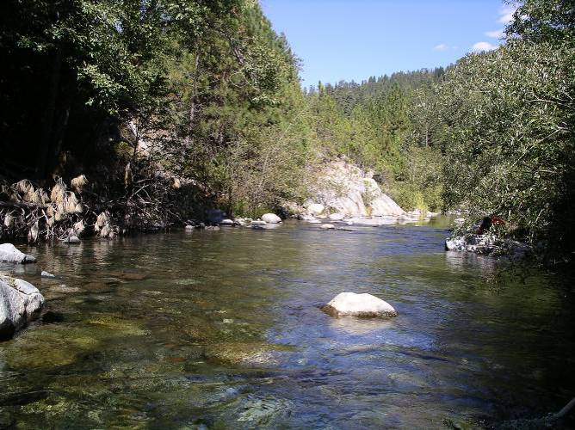
POOL | RUN
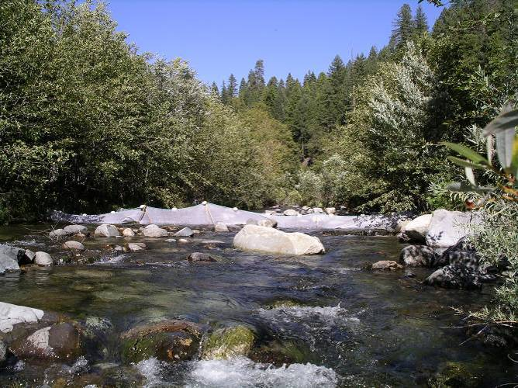 | 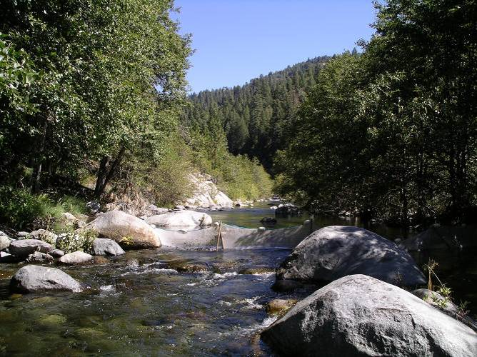
HGR | LGR
Rubicon River

R36.2 (Comparison Reach above Hell Hole Reservoir)
2007 Sampled Mesohabitat Units
Unit Number | Unit Type¹ | Sampling Method² | Length (ft) | Width (ft) | Unit Area (ft²) | Mean Depth (ft) | Max Depth (ft) | % of Total Survey Length | % of Total Survey Area
1 | Pool | E | 132.0 | 25.0 | 3300.0 | 2.3 | 4.6 | 19.2% | 17.2%
2 | Pool | E | 130.0 | 13.0 | 1690.0 | * | * | 18.9% | 8.8%
3 | Pool | E | 240.0 | 45.0 | 10800.0 | 1.8 | 3.3 | 34.9% | 56.4%
Total |  |  | 502.0 | -- | 15790.0 | -- | -- | 73.0% | 82.5%
Average |  |  | 167.3 | 27.7 | 5263.3 | 2.1 | 4.0 | -- | --
4 | Run | E | 72.0 | 7.0 | 504.0 | 0.3 | 0.6 | 10.5% | 2.6%
5 | Run | E | 50.0 | 11.0 | 550.0 | 0.5 | 1.0 | 7.3% | 2.9%
Total |  |  | 122.0 | -- | 1054.0 | -- | -- | 17.7% | 5.5%
Average |  |  | 61.0 | 9.0 | 527.0 | 0.4 | 0.8 | -- | --
6 | HGR | E | 64.0 | 36.0 | 2304.0 | 0.5 | 1.3 | 9.3% | 12.0%
Total |  |  | 64.0 | -- | 2304.0 | -- | -- | 9.3% | 12.0%
Grand Total |  |  | 688.0 | -- | 19148.0 | -- | -- | 100.0% | 100.0%
¹LGR = Low Gradient Riffle; HGR = High Gradient Riffle
²E = Electrofishing

Photos of Representative Habitat Units:
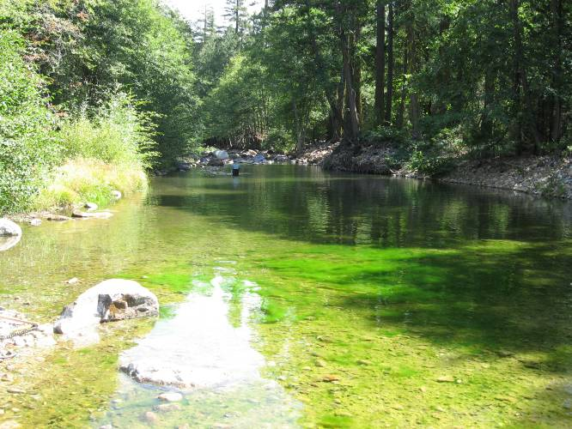 | 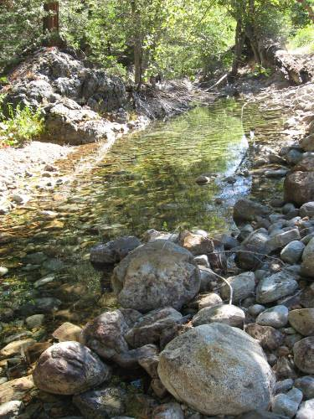
POOL | POOL
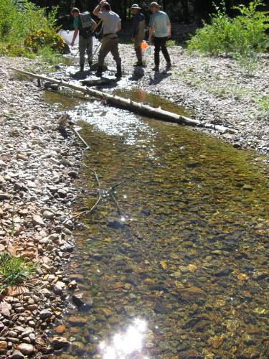 | 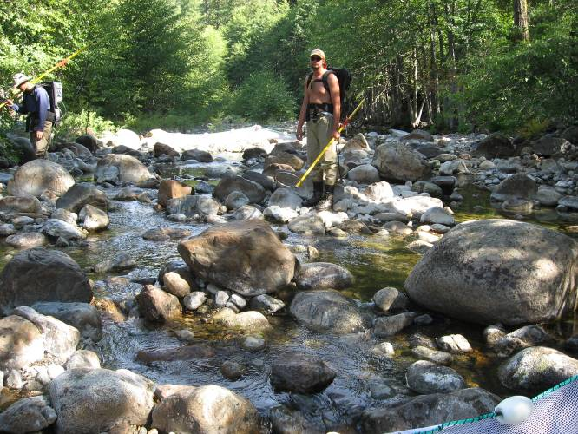
RUN | HGR

Long Canyon Creek

LC9.0 (Bypass Reach)
2007 Sampled Mesohabitat Units
Unit Number | Unit Type¹ | Sampling Method² | Length (ft) | Width (ft) | Unit Area (ft²) | Mean Depth (ft) | Max Depth (ft) | % of Total Survey Length | % of Total Survey Area
1 | Pool | E | 87.0 | 12.0 | 1044.0 | 2.5 | 5.5 | 16.0% | 11.8%
2 | Pool | E | 72.0 | 16.0 | 1152.0 | 1.9 | 4.2 | 13.3% | 13.1%
3 | Pool | E | 150.0 | 18.0 | 2700.0 | 0.6 | 1.8 | 27.6% | 30.6%
Total |  |  | 309.0 | -- | 4896.0 | -- | -- | 56.9% | 55.5%
Average |  |  | 103.0 | 15.3 | 1632.0 | 1.7 | 3.8 | -- | --
4 | Run | E | 63.0 | 15.0 | 945.0 | 0.8 | 1.8 | 11.6% | 10.7%
Total |  |  | 63.0 | -- | 945.0 | -- | -- | 11.6% | 10.7%
5 | HGR | E | 67.0 | 15.0 | 1005.0 | 0.5 | 0.9 | 12.3% | 11.4%
Total |  |  | 67.0 | -- | 1005.0 | -- | -- | 12.3% | 11.4%
6 | LGR | E | 104.0 | 19.0 | 1976.0 | 0.6 | 1.6 | 19.2% | 22.4%
Total |  |  | 104.0 | -- | 1976.0 | -- | -- | 19.2% | 22.4%
Grand Total |  |  | 543.0 | -- | 8822.0 | -- | -- | 100.0% | 100.0%
¹LGR = Low Gradient Riffle; HGR = High Gradient Riffle
²E = Electrofishing

Photos of Representative Habitat Units:
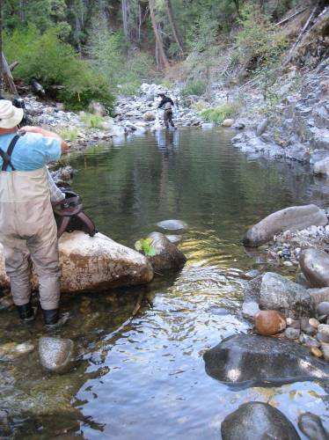 | 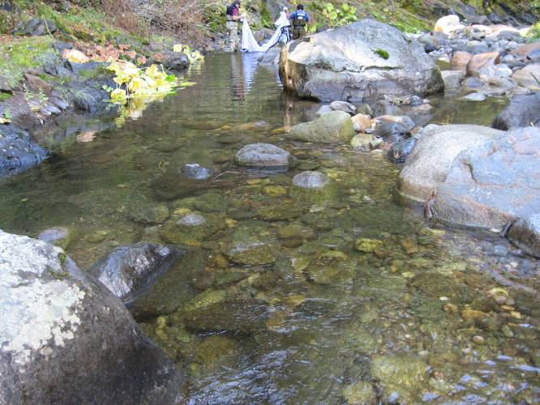
POOL | RUN
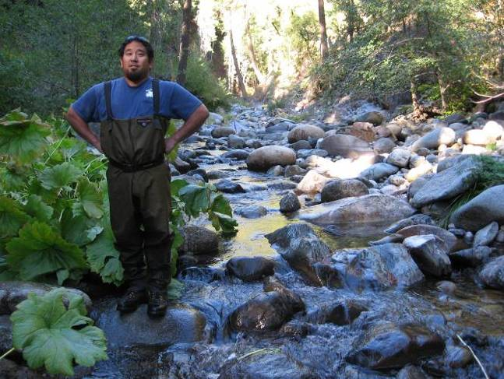 | 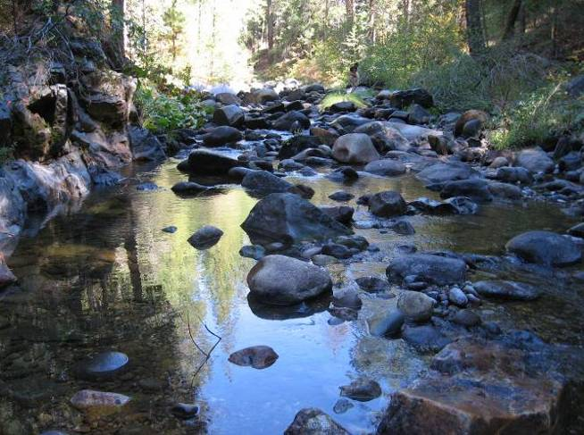
HGR | LGR

North Fork Long Canyon Creek

NFLC1.9 (Bypass Reach)
2007 Sampled Mesohabitat Units
Unit Number | Unit Type¹ | Sampling Method² | Length (ft) | Width (ft) | Unit Area (ft²) | Mean Depth (ft) | Max Depth (ft) | % of Total Survey Length | % of Total Survey Area
1 | Pool | E | 48.0 | 17.0 | 816.0 | 1.5 | 2.8 | 12.0% | 15.5%
2 | Pool | E | 45.0 | 11.0 | 495.0 | 0.6 | 1.1 | 11.3% | 9.4%
3 | Pool | E | 54.0 | 13.0 | 702.0 | 0.9 | 1.6 | 13.5% | 13.3%
Total |  |  | 147.0 | -- | 2013.0 | -- | -- | 36.8% | 38.3%
Average |  |  | 49.0 | 13.7 | 671.0 | 1.0 | 1.8 | -- | --
4 | Run | E | 78.0 | 14.0 | 1092.0 | 0.4 | 1.0 | 19.5% | 20.8%
Total |  |  | 78.0 | -- | 1092.0 | -- | -- | 19.5% | 20.8%
5 | HGR | E | 78.0 | 12.0 | 936.0 | 0.3 | 1.0 | 19.5% | 17.8%
Total |  |  | 78.0 | -- | 936.0 | -- | -- | 19.5% | 17.8%
6 | LGR | E | 36.0 | 13.0 | 468.0 | 0.3 | 0.6 | 9.0% | 8.9%
7 | LGR | E | 60.0 | 12.5 | 750.0 | 0.4 | 0.6 | 15.0% | 14.3%
Total |  |  | 96.0 | -- | 1218.0 | -- | -- | 24.1% | 23.2%
Average |  |  | 48.0 | 12.8 | 609.0 | 0.4 | 0.6 | -- | --
Grand Total |  |  | 399.0 | -- | 5259.0 | -- | -- | 100.0% | 100.0%
¹LGR = Low Gradient Riffle; HGR = High Gradient Riffle
²E = Electrofishing

Photos of Representative Habitat Units:
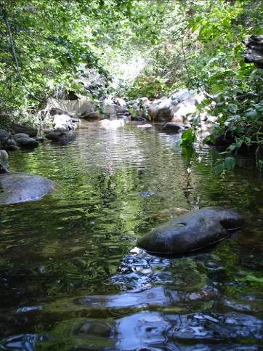 | 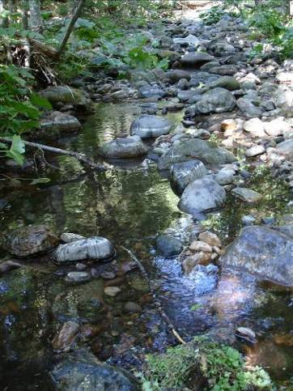
POOL | RUN
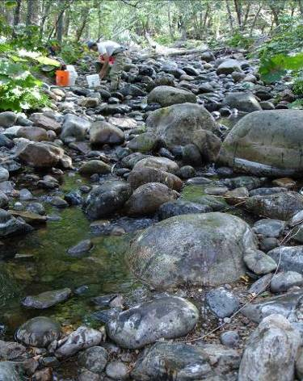 | 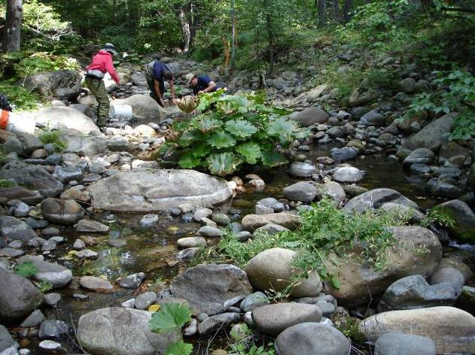
HGR | LGR
North Fork Long Canyon Creek

NFLC3.8 (Comparison Reach above North Fork Long Canyon Diversion)
2007 Sampled Mesohabitat Units
Unit Number | Unit Type¹ | Sampling Method² | Length (ft) | Width (ft) | Unit Area (ft²) | Mean Depth (ft) | Max Depth (ft) | % of Total Survey Length | % of Total Survey Area
1 | Pool | E | 85.0 | 12.0 | 1020.0 | 1.0 | 2.4 | 19.7% | 20.3%
2 | Pool | E | 93.0 | 11.0 | 1023.0 | 1.6 | 0.5 | 21.6% | 20.3%
3 | Pool | E | 25.0 | 16.0 | 400.0 | 0.8 | 1.7 | 5.8% | 7.9%
Total |  |  | 203.0 | -- | 2443.0 | -- | -- | 47.1% | 48.5%
Average |  |  | 67.7 | 13.0 | 814.3 | 1.1 | 1.5 | -- | --
4 | Run | E | 60.0 | 14.0 | 840.0 | 0.4 | 1.2 | 13.9% | 16.7%
Total |  |  | 60.0 | -- | 840.0 | -- | -- | 14% | 17%
5 | HGR | E | 57.0 | 10.0 | 570.0 | 0.4 | 0.8 | 13.2% | 11.3%
6 | HGR | E | 45.0 | 13.0 | 585.0 | 0.3 | 0.6 | 10.4% | 11.6%
Total |  |  | 102.0 | -- | 1155.0 | -- | -- | 23.7% | 23.0%
Average |  |  | 51.0 | 11.5 | 577.5 | 0.3 | 0.7 | -- | --
7 | LGR | E | 66.0 | 9.0 | 594.0 | 0.3 | 0.7 | 15.3% | 11.8%
Total |  |  | 66.0 | -- | 594.0 | -- | -- | 15.3% | 11.8%
Grand Total |  |  | 431.0 | -- | 5032.0 | -- | -- | 100% | 100%
¹LGR = Low Gradient Riffle; HGR = High Gradient Riffle
²E = Electrofishing
Photos of Representative Habitat Units:
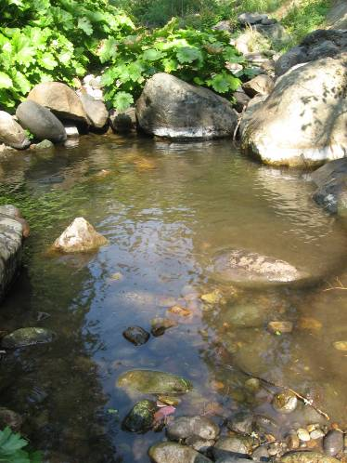 | 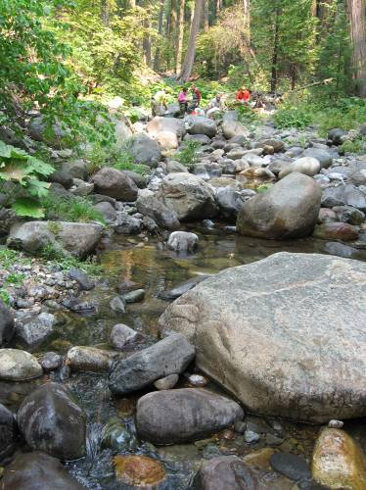
POOL | RUN
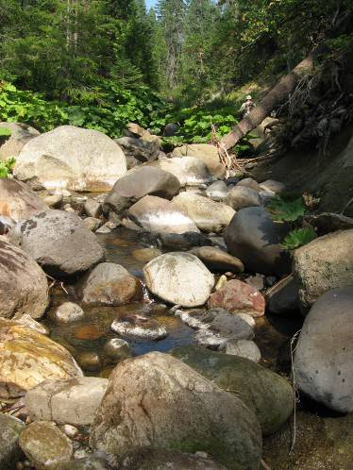 | 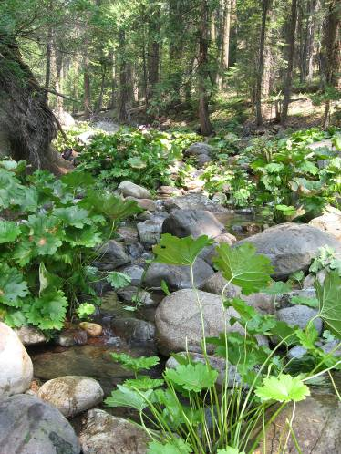
HGR | LGR

South Fork Long Canyon Creek

SFLC2.3 (Bypass Reach)
2007 Sampled Mesohabitat Units
Unit Number | Unit Type¹ | Sampling Method² | Length (ft) | Width (ft) | Unit Area (ft²) | Mean Depth (ft) | Max Depth (ft) | % of Total Survey Length | % of Total Survey Area
1 | Pool | E | 90.0 | 15.0 | 1350.0 | 1.0 | 2.4 | 16.2% | 19.7%
2 | Pool | E | 101.0 | 12.5 | 1262.5 | 1.8 | 2.5 | 18.2% | 18.5%
3 | Pool | E | 96.0 | 14.0 | 1344.0 | 0.8 | 2.1 | 17.3% | 19.6%
Total |  |  | 287.0 | -- | 3956.5 | -- | -- | 51.7% | 57.8%
Average |  |  | 95.7 | 13.8 | 1318.8 | 1.2 | 2.3 | -- | --
4 | Run | E | 64.0 | 8.7 | 556.8 | 0.5 | 0.8 | 11.5% | 8.1%
5 | Run | E | 52.0 | 17.5 | 910.0 | 0.4 | 0.7 | 9.4% | 13.3%
Total |  |  | 116.0 | -- | 1466.8 | -- | -- | 20.9% | 21.4%
Average |  |  | 58.0 | 13.1 | 733.4 | 0.4 | 0.8 | -- | --
6 | HGR | E | 65.0 | 10.3 | 669.5 | 0.3 | 0.9 | 11.7% | 9.8%
Total |  |  | 65.0 | -- | 669.5 | -- | -- | 11.7% | 9.8%
7 | LGR | E | 87.0 | 8.6 | 748.2 | 0.4 | 0.7 | 15.7% | 10.9%
Total |  |  | 87.0 | -- | 748.2 | -- | -- | 15.7% | 10.9%
Grand Total |  |  | 555.0 | -- | 6841.0 | -- | -- | 100.0% | 100.0%
¹LGR = Low Gradient Riffle; HGR = High Gradient Riffle
²E = Electrofishing

2008 Sampled Mesohabitat Units
Unit Number | Unit Type¹ | Sampling Method² | Length (ft) | Width (ft) | Unit Area (ft²) | Mean Depth (ft) | Max Depth (ft) | % of Total Survey Length | % of Total Survey Area
1 | Pool | E | 90.0 | 21.0 | 1890.0 | 0.7 | 1.5 | 16.1% | 25.7%
2 | Pool | E | 100.0 | 16.5 | 1650.0 | 1.4 | 2.3 | 17.9% | 22.5%
3 | Pool | E | 120.0 | 11.0 | 1320.0 | 1.3 | 2.5 | 21.4% | 18.0%
Total |  |  | 310.0 | -- | 4860.0 | -- | -- | 55.4% | 66.2%
Average |  |  | 103.3 | 16.2 | 1620.0 | 1.1 | 2.1 | -- | --
4 | Run | E | 60.0 | 8.0 | 480.0 | 0.4 | 0.8 | 10.7% | 6.5%
5 | Run | E | 45.0 | 17.0 | 765.0 | 0.2 | 0.7 | 8.0% | 10.4%
Total |  |  | 105.0 | -- | 1245.0 | -- | -- | 18.8% | 16.9%
Average |  |  | 52.5 | 12.5 | 622.5 | 0.3 | 0.8 | -- | --
6 | HGR | E | 55.0 | 8.5 | 467.5 | 0.3 | 0.7 | 9.8% | 6.4%
Total |  |  | 55.0 | -- | 467.5 | -- | -- | 9.8% | 6.4%
7 | LGR | E | 90.0 | 8.6 | 774.0 | 0.4 | 0.7 | 16.1% | 10.5%
Total |  |  | 90.0 | -- | 774.0 | -- | -- | 16.1% | 10.5%
Grand Total |  |  | 560.0 | -- | 7346.5 | -- | -- | 100.0% | 100.0%
¹LGR = Low Gradient Riffle; HGR = High Gradient Riffle
²E = Electrofishing

South Fork Long Canyon Creek

SFLC2.3 (Bypass Reach)
2009 Sampled Mesohabitat Units
Unit Number | Unit Type¹ | Sampling Method² | Length (ft) | Width (ft) | Unit Area (ft²) | Mean Depth (ft) | Max Depth (ft) | % of Total Survey Length | % of Total Survey Area
1 | Pool | E | 89.0 | 17.0 | 1513.0 | 1.4 | 2.4 | 15.8% | 20.3%
2 | Pool | E | 90.0 | 17.5 | 1575.0 | 0.7 | 2.3 | 16.0% | 21.1%
3 | Pool | E | 105.0 | 13.0 | 1365.0 | 1.3 | 2.6 | 18.7% | 18.3%
Total |  |  | 284.0 |  | 4453.0 |  |  | 50.5% | 59.7%
Average |  |  | 94.7 | 15.8 | 1484.3 | 1.1 | 2.4
4 | Run | E | 60.0 | 8.0 | 480.0 | 0.4 | 0.8 | 10.7% | 6.4%
5 | Run | E | 40.0 | 14.2 | 568.0 | 0.3 | 0.7 | 7.1% | 7.6%
Total |  |  | 100.0 |  | 1048.0 |  |  | 17.8% | 14.1%
Average |  |  | 50.0 | 11.1 | 524.0 | 0.4 | 0.8
6 | HGR | E | 72.0 | 8.0 | 576.0 | 0.2 | 0.6 | 12.8% | 7.7%
Total |  |  | 72.0 |  | 576.0 |  |  | 12.8% | 7.7%
7 | LGR | E | 106.0 | 13.0 | 1378.0 | 0.3 | 0.7 | 18.9% | 18.5%
Total |  |  | 106.0 |  | 1378.0 |  |  | 18.9% | 18.5%
Grand Total |  |  | 562.0 |  | 7455.0 |  |  | 100.0% | 100.0%
¹LGR = Low Gradient Riffle; HGR = High Gradient Riffle
²E = Electrofishing

Photos of Representative Habitat Units:
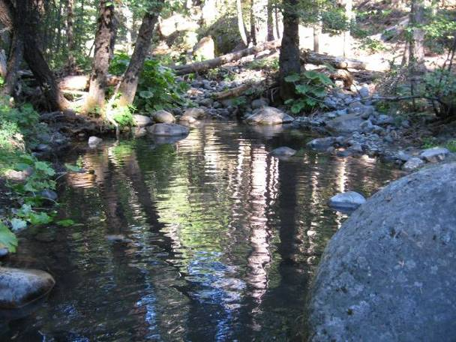 | 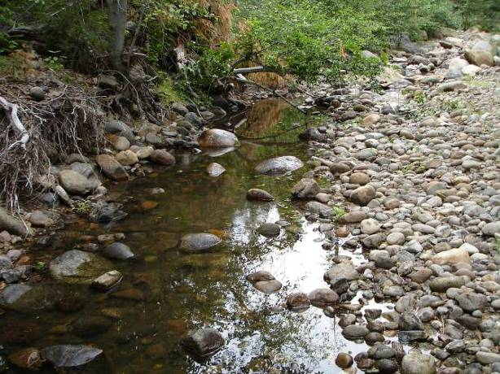
POOL | RUN
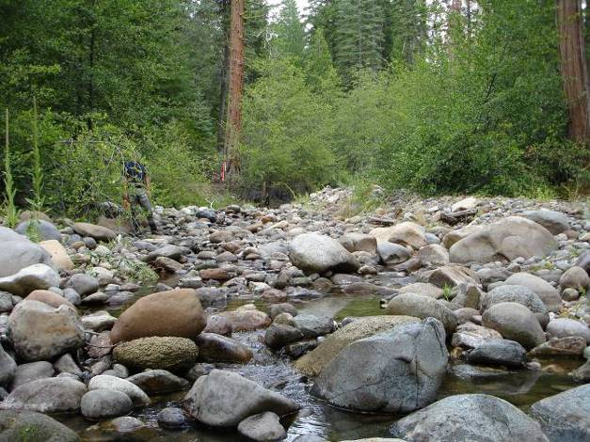 | 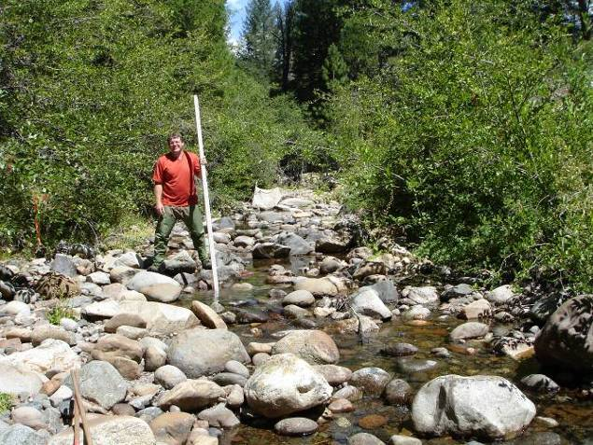
HGR | LGR

South Fork Long Canyon Creek

SFLC3.0 (Bypass Reach)
2009 Sampled Mesohabitat Units
Unit Number | Unit Type¹ | Sampling Method² | Length (ft) | Width (ft) | Unit Area (ft²) | Mean Depth (ft) | Max Depth (ft) | % of Total Survey Length | % of Total Survey Area
1 | Pool | E | 85.0 | 18.0 | 1530.0 | 1.4 | 2.8 | 16.8% | 21.6%
2 | Pool | E | 90.0 | 19.0 | 1710.0 | 1.5 | 3.0 | 17.8% | 24.1%
3 | Pool | E | 80.0 | 14.0 | 1120.0 | 1.2 | 2.3 | 15.8% | 15.8%
Total |  |  | 255.0 |  | 4360.0 |  |  | 50.5% | 61.5%
Average |  |  | 85.0 | 17.0 | 1453.3 | 1.4 | 2.7
4 | Run | E | 55.0 | 7.0 | 385.0 | 0.3 | 1.2 | 10.9% | 5.4%
5 | Run | E | 45.0 | 10.0 | 450.0 | 0.3 | 0.6 | 8.9% | 6.4%
Total |  |  | 100.0 |  | 835.0 |  |  | 19.8% | 11.8%
Average |  |  | 50.0 | 8.5 | 417.5 | 0.3 | 0.9
6 | HGR | E | 60.0 | 12.0 | 720.0 | 0.3 | 0.7 | 11.9% | 10.2%
Total |  |  | 60.0 |  | 720.0 |  |  | 11.9% | 10.2%
7 | LGR | E | 90.0 | 13.0 | 1170.0 | 0.3 | 0.6 | 17.8% | 16.5%
Total |  |  | 90.0 |  | 1170.0 |  |  | 17.8% | 16.5%
Grand Total |  |  | 505.0 |  | 7085.0 |  |  | 100.0% | 100.0%
¹LGR = Low Gradient Riffle; HGR = High Gradient Riffle
²E = Electrofishing
Photos of Representative Habitat Units:
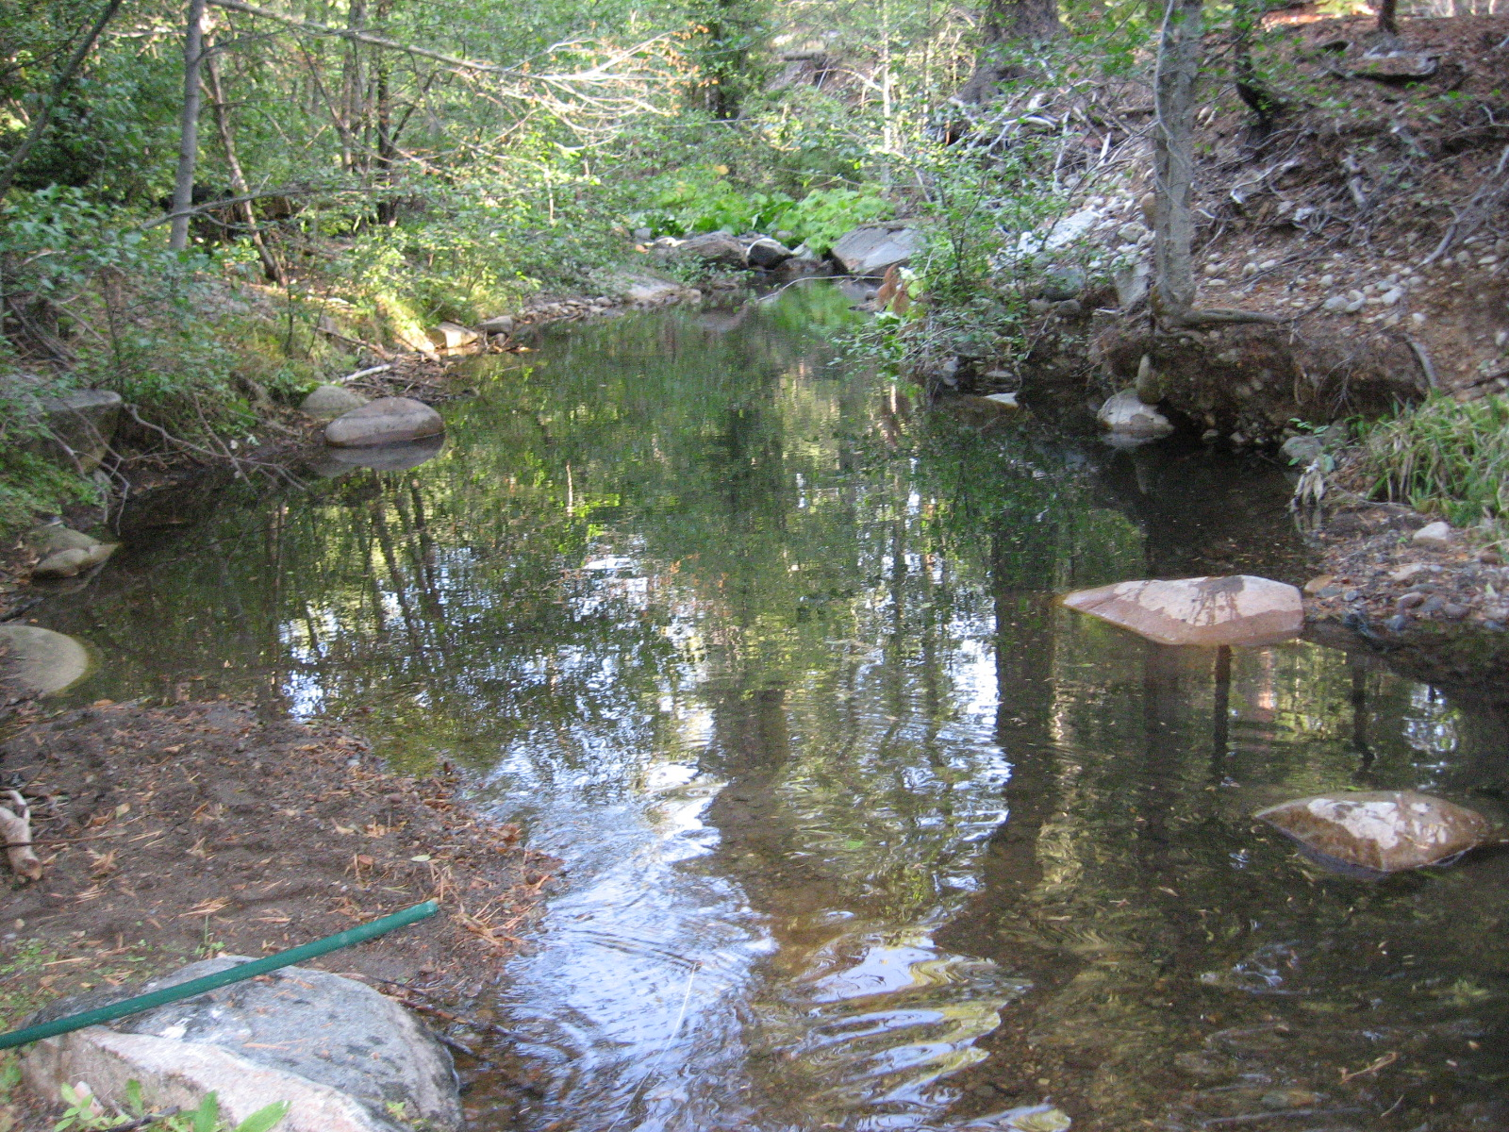 | 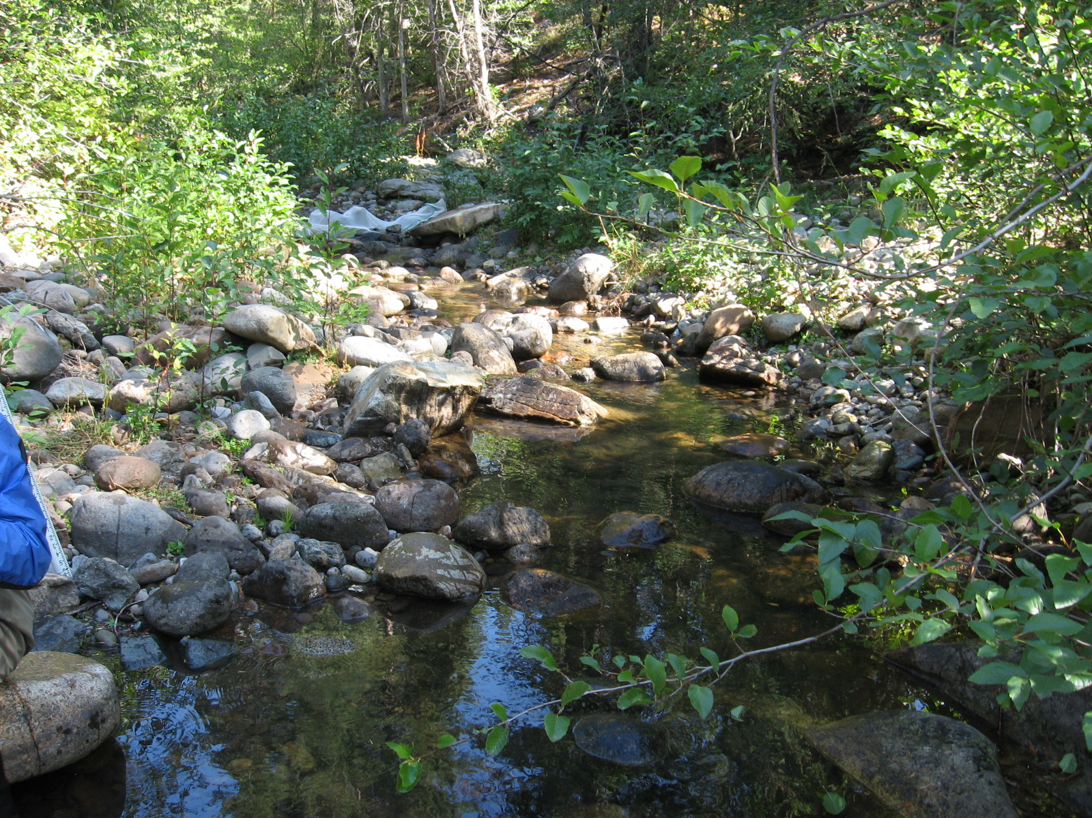
POOL | RUN
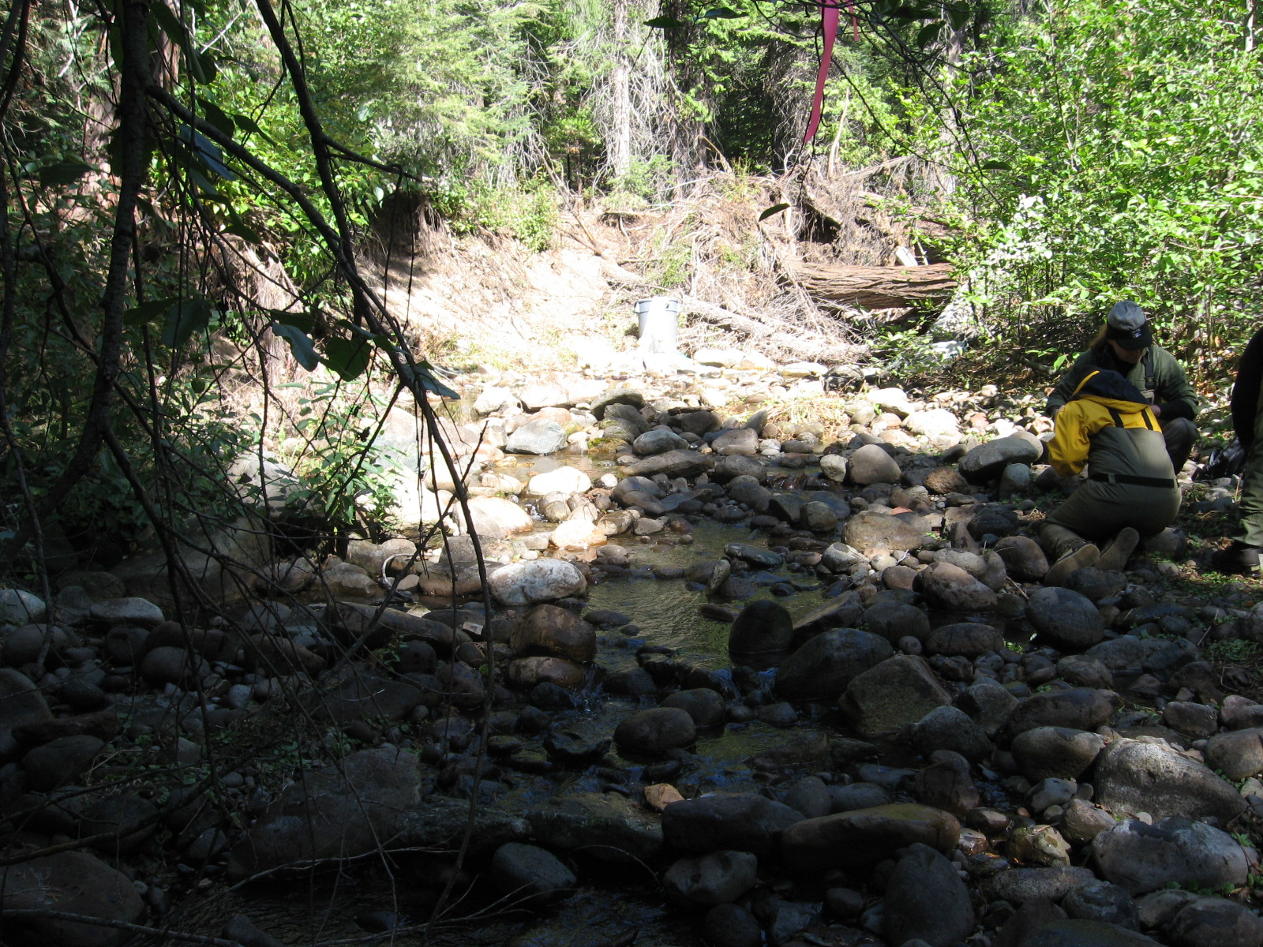 | 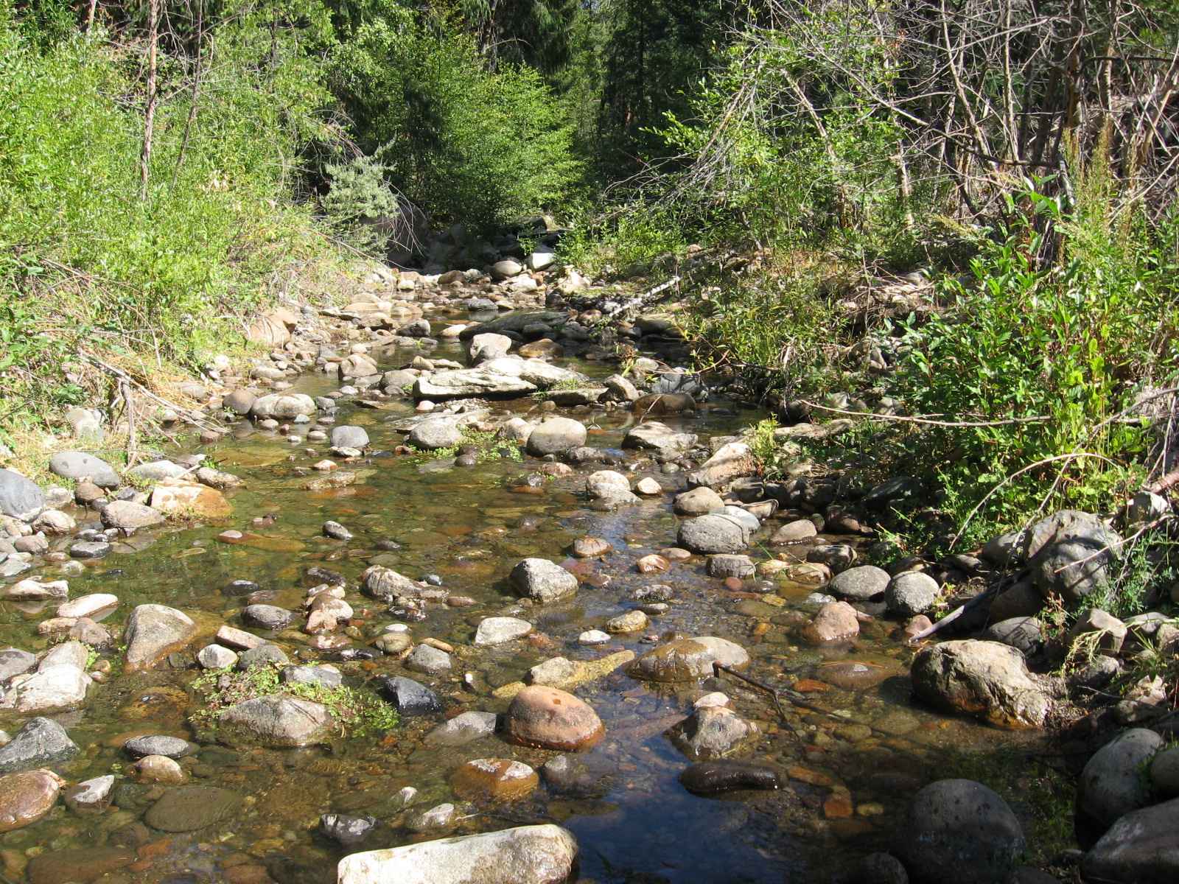
HGR | LGR

South Fork Long Canyon Creek

SFLC4.2 (Comparison Reach above South Fork Long Canyon Diversion)
2007 Sampled Mesohabitat Units
Unit Number | Unit Type¹ | Sampling Method² | Length (ft) | Width (ft) | Unit Area (ft²) | Mean Depth (ft) | Max Depth (ft) | % of Total Survey Length | % of Total Survey Area
1 | Pool | E | 112.0 | 13.0 | 1456.0 | 1.7 | 3.4 | 23.1% | 28.3%
2 | Pool | E | 63.0 | 12.5 | 787.5 | 1.3 | 2.8 | 13.0% | 15.3%
3 | Pool | E | 60.0 | 13.5 | 810.0 | 0.7 | 2.1 | 12.4% | 15.8%
Total |  |  | 235.0 | -- | 3053.5 | -- | -- | 48.5% | 59.4%
Average |  |  | 78.3 | 13.0 | 1017.8 | 1.2 | 2.8 | -- | --
4 | Run | E | 55.0 | 7.0 | 385.0 | 0.4 | 0.9 | 11.3% | 7.5%
5 | Run | E | 47.0 | 8.5 | 399.5 | 0.5 | 1.0 | 9.7% | 7.8%
Total |  |  | 102.0 | -- | 784.5 | -- | -- | 21.0% | 15.3%
Average |  |  | 51.0 | 7.8 | 392.3 | 0.5 | 1.0 | -- | --
6 | HGR | E | 59.0 | 7.0 | 413.0 | 0.3 | 0.9 | 12.2% | 8.0%
Total |  |  | 59.0 | -- | 413.0 | -- | -- | 12.2% | 8.0%
7 | LGR | E | 89.0 | 10.0 | 890.0 | 0.3 | 0.6 | 18.4% | 17.3%
Total |  |  | 89.0 | -- | 890.0 | -- | -- | 18.4% | 17.3%
Grand Total |  |  | 485.0 | -- | 5141.0 | -- | -- | 100.0% | 100.0%
¹LGR = Low Gradient Riffle; HGR = High Gradient Riffle
²E = Electrofishing

2008 Sampled Mesohabitat Units
Unit Number | Unit Type¹ | Sampling Method² | Length (ft) | Width (ft) | Unit Area (ft²) | Mean Depth (ft) | Max Depth (ft) | % of Total Survey Length | % of Total Survey Area
1 | Pool | E | 112.0 | 11.2 | 1254.4 | 1.4 | 2.9 | 23.5% | 25.5%
2 | Pool | E | 63.0 | 13.0 | 819.0 | 1.2 | 3.4 | 13.2% | 16.7%
3 | Pool | E | 60.0 | 14.0 | 840.0 | 1.3 | 3.4 | 12.6% | 17.1%
Total |  |  | 235.0 | -- | 2913.4 | -- | -- | 49.4% | 59.3%
Average |  |  | 78.3 | 12.7 | 971.1 | 1.3 | 3.2 | -- | --
4 | Run | E | 50.0 | 7.0 | 350.0 | 0.4 | 0.9 | 10.5% | 7.1%
5 | Run | E | 42.0 | 4.5 | 189.0 | 0.4 | 0.7 | 8.8% | 3.8%
Total |  |  | 92.0 | -- | 539.0 | -- | -- | 19.3% | 11.0%
Average |  |  | 46.0 | 5.8 | 269.5 | 0.4 | 0.8 | -- | --
6 | HGR | E | 60.0 | 6.5 | 390.0 | 0.3 | 0.7 | 12.6% | 7.9%
Total |  |  | 60.0 | -- | 390.0 | -- | -- | 12.6% | 7.9%
7 | LGR | E | 89.0 | 12.0 | 1068.0 | 0.3 | 0.9 | 18.7% | 21.7%
Total |  |  | 89.0 | -- | 1068.0 | -- | -- | 18.7% | 21.7%
Grand Total |  |  | 476.0 | -- | 4910.4 | -- | -- | 100.0% | 100.0%
¹LGR = Low Gradient Riffle; HGR = High Gradient Riffle
²E = Electrofishing
South Fork Long Canyon Creek

SFLC4.2 (Comparison Reach above South Fork Long Canyon Diversion)
2009 Sampled Mesohabitat Units
Unit Number | Unit Type¹ | Sampling Method² | Length (ft) | Width (ft) | Unit Area (ft²) | Mean Depth (ft) | Max Depth (ft) | % of Total Survey Length | % of Total Survey Area
1 | Pool | E | 100.0 | 14.0 | 1400.0 | 1.4 | 3.1 | 20.9% | 24.1%
2 | Pool | E | 62.0 | 11.0 | 682.0 | 1.1 | 2.5 | 13.0% | 11.7%
3 | Pool | E | 60.0 | 13.0 | 780.0 | 1.2 | 3.2 | 12.6% | 13.4%
Total |  |  | 222.0 |  | 2862.0 |  |  | 46.4% | 49.2%
Average |  |  | 74.0 | 12.7 | 954.0 | 1.2 | 2.9
4 | Run | E | 61.0 | 16.0 | 976.0 | 0.4 | 0.8 | 12.8% | 16.8%
5 | Run | E | 45.0 | 10.0 | 450.0 | 0.4 | 1.1 | 9.4% | 7.7%
Total |  |  | 106.0 |  | 1426.0 |  |  | 22.2% | 24.5%
Average |  |  | 53.0 | 13.0 | 713.0 | 0.4 | 1.0
6 | HGR | E | 60.0 | 4.5 | 270.0 | 0.3 | 1.3 | 12.6% | 4.6%
Total |  |  | 60.0 |  | 270.0 |  |  | 12.6% | 4.6%
7 | LGR | E | 90.0 | 14.0 | 1260.0 | 0.3 | 0.7 | 18.8% | 21.7%
Total |  |  | 90.0 |  | 1260.0 |  |  | 18.8% | 21.7%
Grand Total |  |  | 478.0 |  | 5818.0 |  |  | 100.0% | 100.0%
¹LGR = Low Gradient Riffle; HGR = High Gradient Riffle
²E = Electrofishing
Photos of Representative Habitat Units:
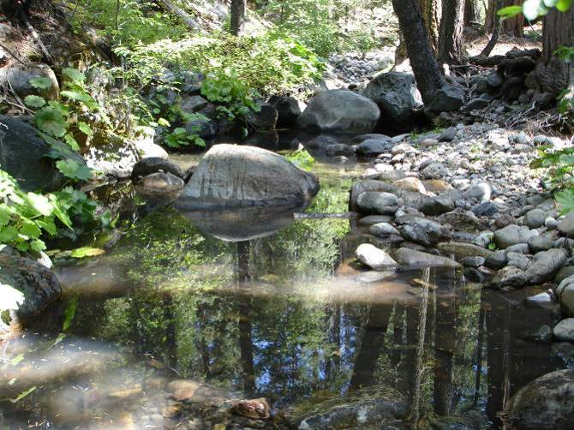 | 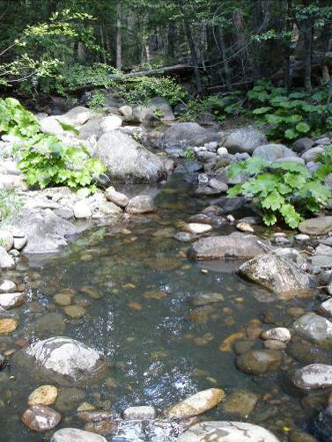
POOL | RUN
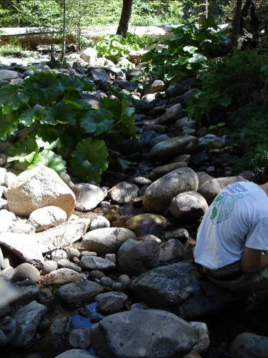 | 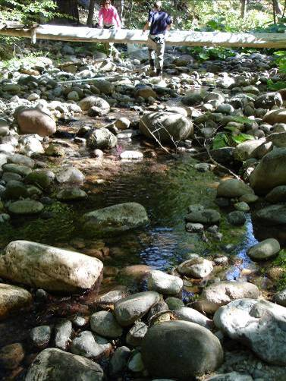
HGR | LGR
South Fork Long Canyon Creek

SFLC5.2 (Comparison Reach above South Fork Long Canyon Diversion)
2009 Sampled Mesohabitat Units
Unit Number | Unit Type¹ | Sampling Method² | Length (ft) | Width (ft) | Unit Area (ft²) | Mean Depth (ft) | Max Depth (ft) | % of Total Survey Length | % of Total Survey Area
1 | Pool | E | 61.0 | 12.0 | 732.0 | 0.7 | 1.3 | 14.0% | 16.8%
2 | Pool | E | 60.0 | 14.0 | 840.0 | 0.8 | 2.5 | 13.8% | 19.3%
3 | Pool | E | 60.0 | 11.0 | 660.0 | 1.0 | 2.0 | 13.8% | 15.2%
Total |  |  | 181.0 |  | 2232.0 |  |  | 41.6% | 51.3%
Average |  |  | 60.3 | 12.3 | 744.0 | 0.8 | 1.9
4 | Run | E | 51.0 | 10.0 | 510.0 | 0.4 | 1.0 | 11.7% | 11.7%
5 | Run | E | 48.0 | 11.5 | 552.0 | 0.3 | 0.6 | 11.0% | 12.7%
Total |  |  | 99.0 |  | 1062.0 |  |  | 22.8% | 24.4%
Average |  |  | 49.5 | 10.8 | 531.0 | 0.4 | 0.8
6 | HGR | E | 65.0 | 8.0 | 520.0 | 0.4 | 1.2 | 14.9% | 11.9%
Total |  |  | 65.0 |  | 520.0 |  |  | 14.9% | 11.9%
7 | LGR | E | 90.0 | 6.0 | 540.0 | 0.2 | 0.5 | 20.7% | 12.4%
Total |  |  | 90.0 |  | 540.0 |  |  | 20.7% | 12.4%
Grand Total |  |  | 435.0 |  | 4354.0 |  |  | 100.0% | 100.0%
¹LGR = Low Gradient Riffle; HGR = High Gradient Riffle
²E = Electrofishing
Photos of Representative Habitat Units:
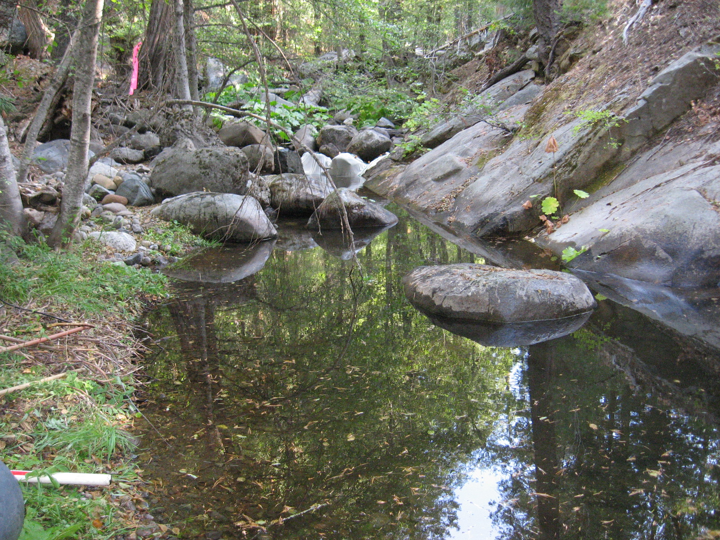 | 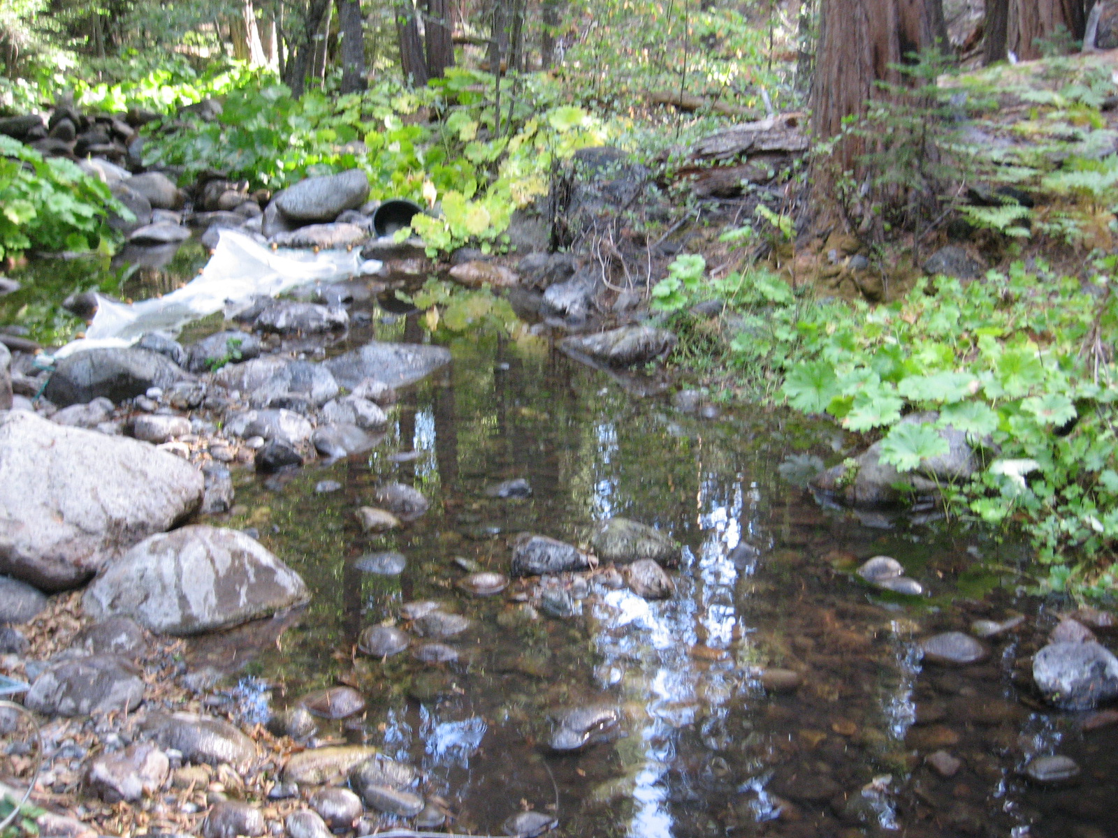
POOL | RUN
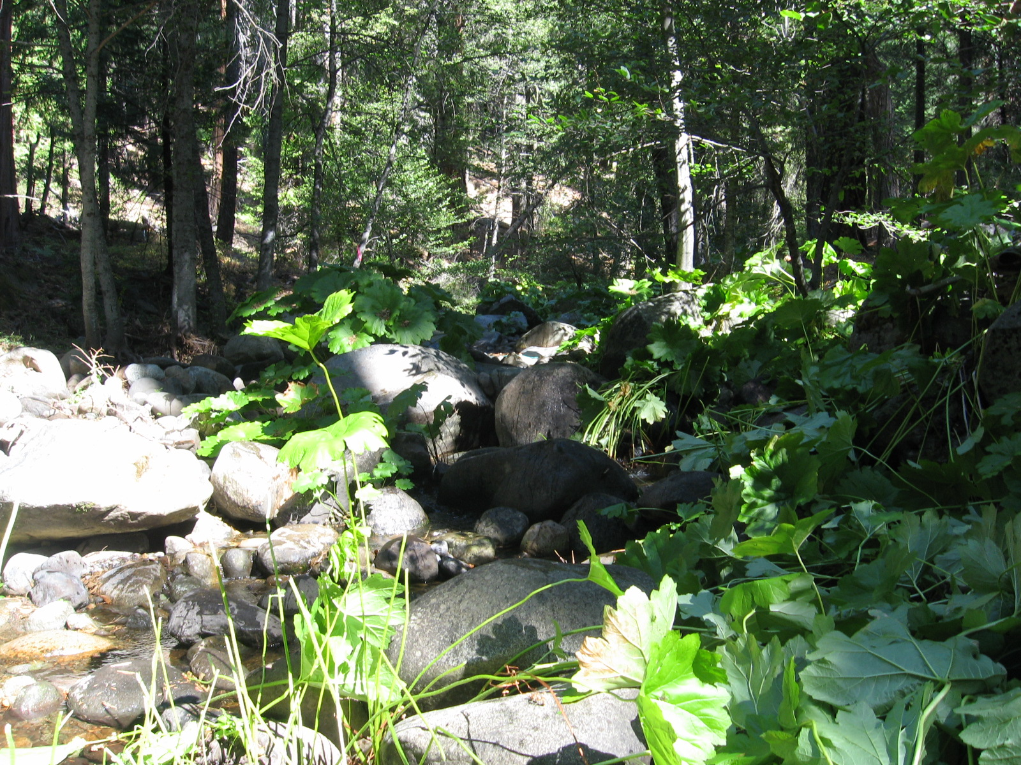 | 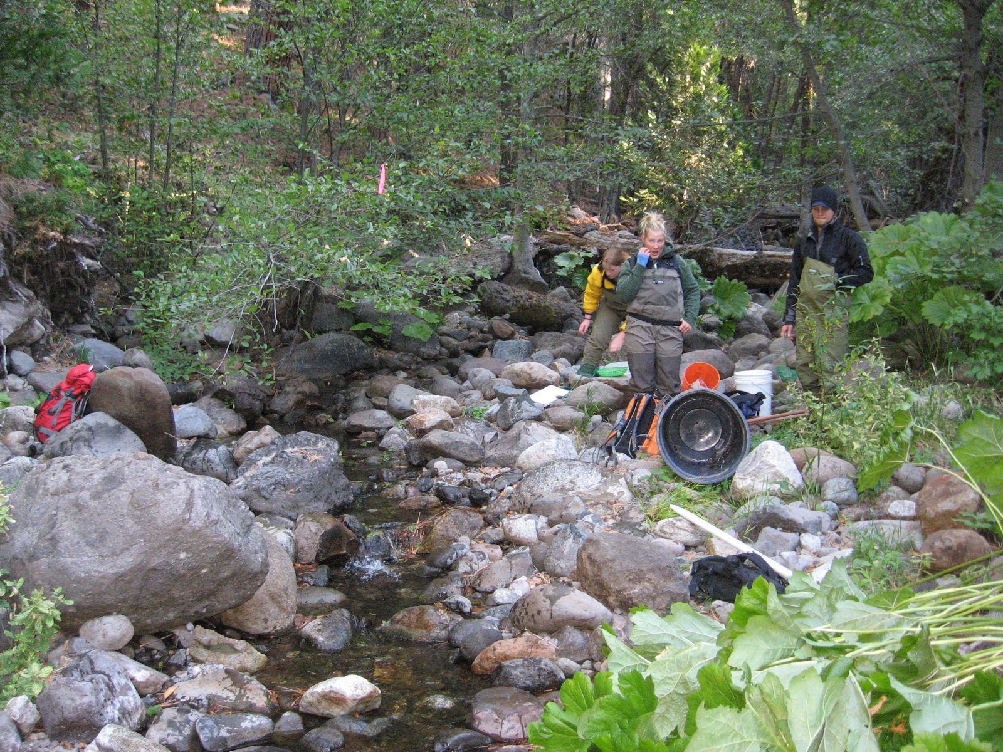
HGR | LGR

Duncan Creek

D6.3 (Bypass Reach)
2007 Sampled Mesohabitat Units
Unit Number | Unit Type¹ | Sampling Method² | Length (ft) | Width (ft) | Unit Area (ft²) | Mean Depth (ft) | Max Depth (ft) | % of Total Survey Length | % of Total Survey Area
1 | Pool | E | 76.0 | 17.1 | 1299.6 | 0.8 | 2.0 | 17.04% | 14.50%
2 | Pool | E | 96.0 | 25.5 | 2448.0 | 1.4 | 2.1 | 21.52% | 27.31%
3 | Pool | E | 66.0 | 33.0 | 2178.0 | 1.7 | 3.0 | 14.80% | 24.30%
Total |  |  | 238.0 | -- | 5925.6 | -- | -- | 53.36% | 66.11%
Average |  |  | 111.0 | 45.0 | 10551.6 | 1.3 | 2.4 | -- | --
4 | Run | E | 69.0 | 8.0 | 552.0 | 1.0 | 2.0 | 15.47% | 6.16%
Total |  |  | 69.0 | 8.0 | 552.0 | 1.0 | 2.0 | 15.47% | 6.16%
5 | HGR | E | 100.0 | 19.0 | 1900.0 | 0.8 | 1.2 | 22.42% | 21.20%
Total |  |  | 100.0 | 19.0 | 1900.0 | 0.8 | 1.2 | 22.42% | 21.20%
6 | LGR | E | 39.0 | 15.0 | 585.0 | 0.5 | 1.0 | 8.74% | 6.53%
Total |  |  | 39.0 | 15.0 | 585.0 | 0.5 | 1.0 | 8.74% | 6.53%
Grand Total |  |  | 446.0 |  | 8962.6 |  |  | 100.0% | 100.0%
¹LGR = Low Gradient Riffle; HGR = High Gradient Riffle
²E = Electrofishing

2008 Sampled Mesohabitat Units
Unit Number | Unit Type¹ | Sampling Method² | Length (ft) | Width (ft) | Unit Area (ft²) | Mean Depth (ft) | Max Depth (ft) | % of Total Survey Length | % of Total Survey Area
1 | Pool | E | 76.0 | 17.1 | 1299.6 | 1.5 | 2.6 | 16.7% | 13.6%
2 | Pool | E | 96.0 | 26.0 | 2496.0 | 1.0 | 2.4 | 21.1% | 26.2%
3 | Pool | E | 66.0 | 33.0 | 2178.0 | 3.0 | 3.9 | 14.5% | 22.9%
Total |  |  | 238.0 | -- | 5973.6 | -- | -- | 52.2% | 62.7%
Average |  |  | 79.3 | 25.4 | 1991.2 | 1.8 | 3.0
4 | Run | E | 69.0 | 8.0 | 552.0 | 2.3 | 2.8 | 15.1% | 5.8%
Total |  |  | 69.0 | -- | 552.0 | -- | -- | 15.1% | 5.8%
5 | HGR | E | 110.0 | 22.0 | 2420.0 | 0.5 | 1.2 | 24.1% | 25.4%
Total |  |  | 110.0 | -- | 2420.0 | -- | -- | 24.1% | 25.4%
6 | LGR | E | 39.0 | 15.0 | 585.0 | 0.6 | 1.2 | 8.6% | 6.1%
Total |  |  | 39.0 | -- | 585.0 | -- | -- | 8.6% | 6.1%
Grand Total |  |  | 456.0 | -- | 9530.6 | -- | -- | 100.0% | 100.0%
¹LGR = Low Gradient Riffle; HGR = High Gradient Riffle
²E = Electrofishing

Duncan Creek

D6.3 (Bypass Reach)

Photos of Representative Habitat Units:
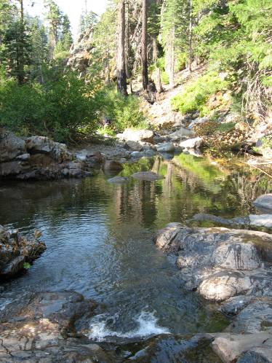 | 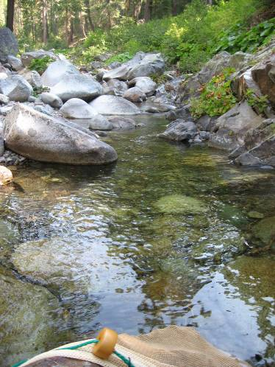
POOL | RUN
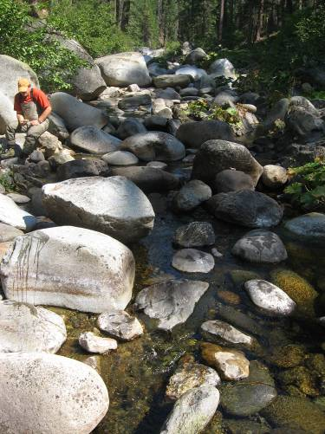 | 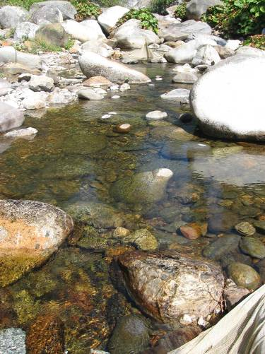
HGR | LGR
Duncan Creek

D8.3 (Bypass Reach)
2008 Sampled Mesohabitat Units
Unit Number | Unit Type¹ | Sampling Method² | Length (ft) | Width (ft) | Unit Area (ft²) | Mean Depth (ft) | Max Depth (ft) | % of Total Survey Length | % of Total Survey Area
1 | Pool | E | 61.5 | 18.0 | 1107.0 | 1.7 | 2.6 | 14.0% | 15.1%
2 | Pool | E | 68.0 | 16.0 | 1088.0 | 2.4 | 4.0 | 15.5% | 14.8%
3 | Pool | E | 103.0 | 22.0 | 2266.0 | 1.2 | 4.0 | 23.5% | 30.9%
Total |  |  | 232.5 | -- | 4461.0 | -- | -- | 53.0% | 60.7%
Average |  |  | 77.5 | 18.7 | 1487.0 | 1.8 | 3.5
4 | Run | E | 60.0 | 12.5 | 750.0 | 0.7 | 1.2 | 13.7% | 10.2%
Total |  |  | 60.0 | -- | 750.0 | -- | -- | 13.7% | 10.2%
5 | HGR | E | 89.0 | 15.0 | 1335.0 | 0.5 | 11.5 | 20.3% | 18.2%
Total |  |  | 89.0 | -- | 1335.0 | -- | -- | 20.3% | 18.2%
6 | LGR | E | 57.0 | 14.0 | 798.0 | 0.8 | 1.6 | 13.0% | 10.9%
Total |  |  | 57.0 | -- | 798.0 | -- | -- | 13.0% | 10.9%
Grand Total |  |  | 438.5 | -- | 7344.0 | -- | -- | 100.0% | 100.0%
¹LGR = Low Gradient Riffle; HGR = High Gradient Riffle
²E = Electrofishing

Photos of Representative Habitat Units:
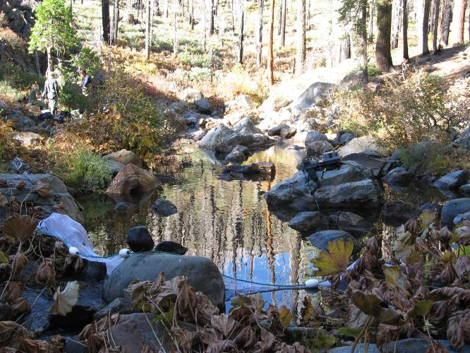 | 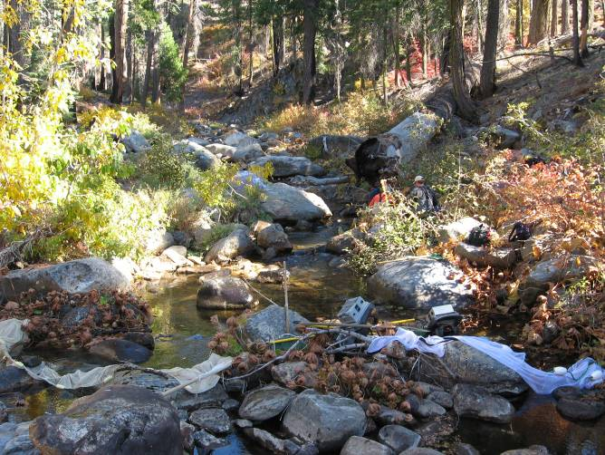
POOL | RUN
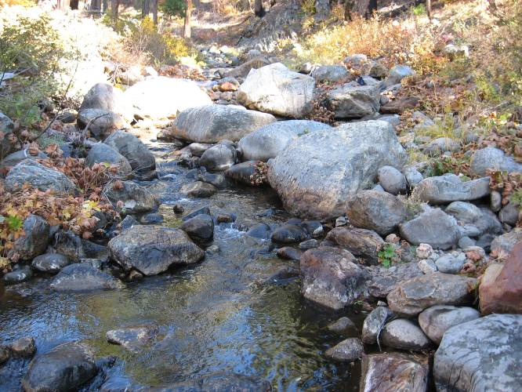 | 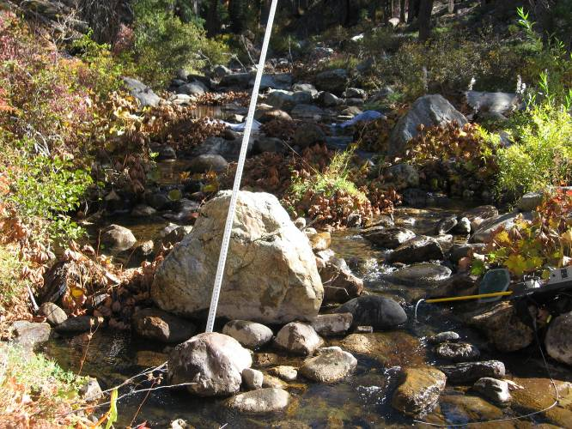
HGR | LGR
Duncan Creek

D9.0 (Comparison Reach above Duncan Diversion)
2007 Sampled Mesohabitat Units
Unit Number | Unit Type¹ | Sampling Method² | Length (ft) | Width (ft) | Unit Area (ft²) | Mean Depth (ft) | Max Depth (ft) | % of Total Survey Length | % of Total Survey Area
1 | Pool | E | 87.0 | 24.5 | 2131.5 | 0.8 | 2.3 | 19.0% | 22.0%
2 | Pool | E | 109.0 | 28.0 | 3052.0 | 1.2 | 3.1 | 23.9% | 31.5%
3 | Pool | E | 60.0 | 20.0 | 1200.0 | 1.5 | 3.3 | 13.1% | 12.4%
Total |  |  | 256.0 | -- | 6383.5 | -- | -- | 56.0% | 65.8%
Average |  |  | 85.3 | 24.2 | 2127.8 | 1.2 | 2.9 | -- | --
4 | Run | E | 60.0 | 15.0 | 900.0 | 0.8 | 1.4 | 13.1% | 9.3%
Total |  |  | 60.0 | -- | 900.0 | -- | -- | 13.1% | 9.3%
5 | HGR | E | 90.0 | 11.0 | 990.0 | 0.7 | 1.5 | 19.7% | 10.2%
Total |  |  | 90.0 | -- | 990.0 | -- | -- | 19.7% | 10.2%
6 | LGR | E | 51.0 | 28.0 | 1428.0 | 0.4 | 0.9 | 11.2% | 14.7%
Total |  |  | 51.0 | -- | 1428.0 | -- | -- | 11.2% | 14.7%
Grand Total |  |  | 457.0 | -- | 9701.5 | -- | -- | 100.0% | 100.0%
¹LGR = Low Gradient Riffle; HGR = High Gradient Riffle
²E = Electrofishing

2008 Sampled Mesohabitat Units
Unit Number | Unit Type¹ | Sampling Method² | Length (ft) | Width (ft) | Unit Area (ft²) | Mean Depth (ft) | Max Depth (ft) | % of Total Survey Length | % of Total Survey Area
1 | Pool | E | 85.0 | 25.0 | 2125.0 | 1.2 | 2.5 | 18.6% | 24.2%
2 | Pool | E | 109.0 | 14.0 | 1526.0 | 1.8 | 3.2 | 23.8% | 17.4%
3 | Pool | E | 60.0 | 19.0 | 1140.0 | 1.4 | 3.1 | 13.1% | 13.0%
Total |  |  | 254.0 | -- | 4791.0 | -- | -- | 55.5% | 54.6%
Average |  |  | 84.7 | 19.3 | 1597.0 | 1.5 | 2.9
4 | Run | E | 60.0 | 14.0 | 840.0 | 0.6 | 1.5 | 13.1% | 9.6%
Total |  |  | 60.0 | -- | 840.0 | -- | -- | 13.1% | 9.6%
5 | HGR | E | 92.0 | 15.0 | 1380.0 | 0.5 | 2.0 | 20.1% | 15.7%
Total |  |  | 92.0 | -- | 1380.0 | -- | -- | 20.1% | 15.7%
6 | LGR | E | 52.0 | 34.0 | 1768.0 | 0.5 | 1.0 | 11.4% | 20.1%
Total |  |  | 52.0 | -- | 1768.0 | -- | -- | 11.4% | 20.1%
Grand Total |  |  | 458.0 | -- | 8779.0 | -- | -- | 100.0% | 100.0%
¹LGR = Low Gradient Riffle; HGR = High Gradient Riffle
²E = Electrofishing
Duncan Creek

D9.0 (Comparison Reach above Duncan Diversion)

Photos of Representative Habitat Units:
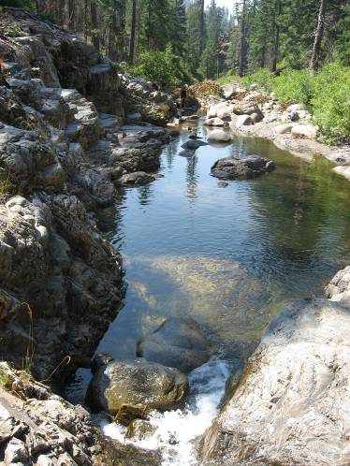 | 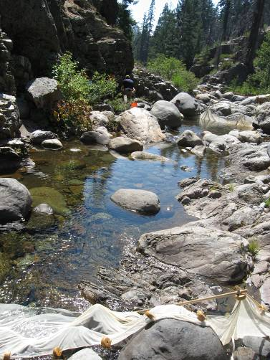
POOL | RUN
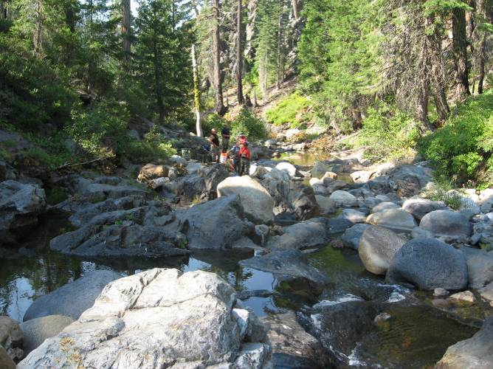 | 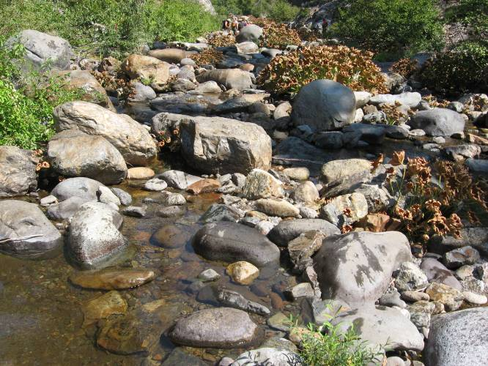
HGR | LGR
Duncan Creek

D10.0 (Comparison Reach above Duncan Diversion)

2008 Sampled Mesohabitat Units
Unit Number | Unit Type¹ | Sampling Method² | Length (ft) | Width (ft) | Unit Area (ft²) | Mean Depth (ft) | Max Depth (ft) | % of Total Survey Length | % of Total Survey Area
1 | Pool | E | 77.0 | 17.0 | 1309.0 | 1.1 | 2.4 | 17.3% | 16.2%
2 | Pool | E | 40.0 | 60.0 | 2400.0 | 1.2 | 2.1 | 9.0% | 29.6%
3 | Pool | E | 120.0 | 17.0 | 2040.0 | 2.9 | 3.8 | 26.9% | 25.2%
Total |  |  | 237.0 | -- | 5749.0 | -- | -- | 53.1% | 71.0%
Average |  |  | 79.0 | 31.3 | 1916.3 | 1.7 | 2.8 | -- | --
4 | Run | E | 66.0 | 7.0 | 462.0 | 0.3 | 1.5 | 14.8% | 5.7%
Total |  |  | 66.0 | -- | 462.0 | -- | -- | 14.8% | 5.7%
5 | HGR | E | 91.0 | 11.0 | 1001.0 | 0.3 | 1.9 | 20.4% | 12.4%
Total |  |  | 91.0 | -- | 1001.0 | -- | -- | 20.4% | 12.4%
6 | LGR | E | 52.0 | 17.0 | 884.0 | 0.3 | 1.5 | 11.7% | 10.9%
Total |  |  | 52.0 | -- | 884.0 | -- | -- | 11.7% | 10.9%
Grand Total |  |  | 446.0 | -- | 8096.0 | -- | -- | 100.0% | 100.0%
¹LGR = Low Gradient Riffle; HGR = High Gradient Riffle
²S = Snorkeling; E = Electrofishing

Photos of Representative Habitat Units:
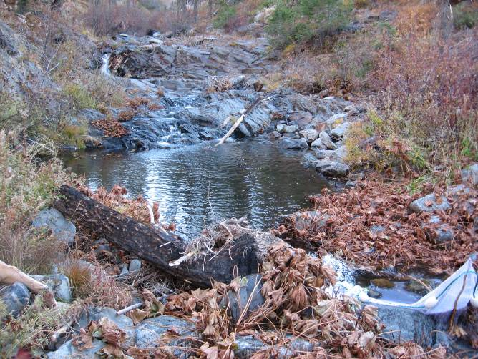 | 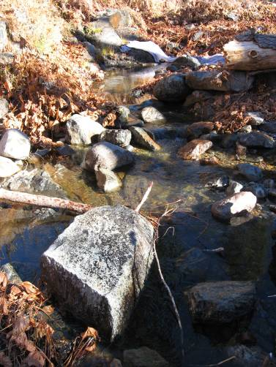
POOL | RUN
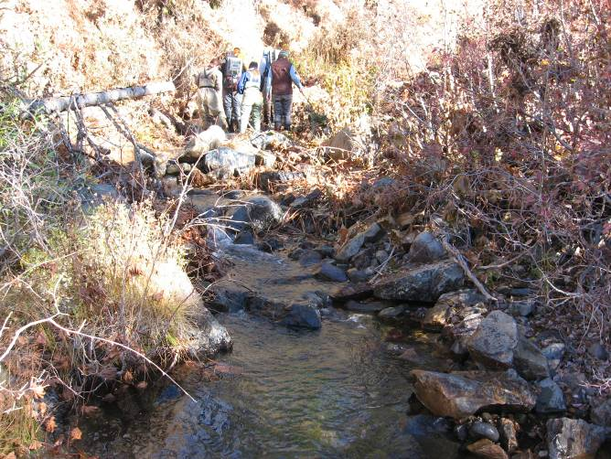 | 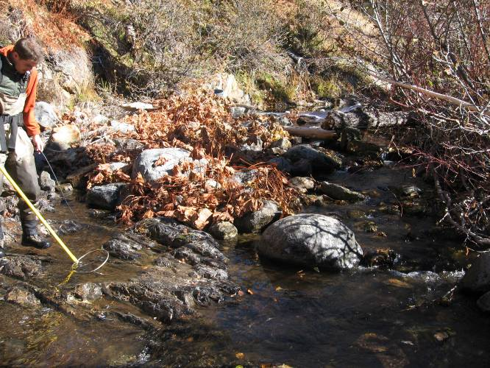
HGR | LGR

North Fork of the Middle Fork American River

NFMF2.3 (Bypass Reach)
2007 Sampled Mesohabitat Units
Unit Number | Unit Type¹ | Sampling Method² | Length (ft) | Width (ft) | Unit Area (ft²) | Mean Depth (ft) | Max Depth (ft) | % of Total Survey Length | % of Total Survey Area
1 | Pool | S | 145.0 | 33.0 | 4785.0 | * | 8.0 | 17.7% | 14.1%
2 | Pool | S | 153.0 | 46.0 | 7038.0 | * | 8.5 | 18.7% | 20.7%
3 | Pool | S | 162.0 | 37.0 | 5994.0 | * | 8.5 | 19.8% | 17.6%
4 | Pool | S | 75.0 | 45.0 | 3375.0 | * | 3.5 | 9.2% | 9.9%
Total |  |  | 535.0 | -- | 21192.0 | -- | -- | 65.4% | 62.4%
Average |  |  | 133.8 | 40.3 | 5298.0 | -- | 7.1 | -- | --
5 | Run | E | 48.0 | 48.0 | 2304.0 | 1.4 | 3.0 | 5.9% | 6.8%
6 | Run | E | 75.0 | 50.0 | 3750.0 | 1.1 | 2.6 | 9.2% | 11.0%
Total |  |  | 123.0 | -- | 6054.0 | -- | -- | 15.0% | 17.8%
Average |  |  | 61.5 | 49.0 | 3027.0 | 1.3 | 2.8 | -- | --
7 | HGR | E | 160.0 | 42.0 | 6720.0 | 0.6 | 4.2 | 19.6% | 19.8%
Total |  |  | 160.0 |  | 6720.0 |  |  | 19.6% | 19.8%
Grand Total |  |  | 818.0 | -- | 33966.0 | -- | -- | 100.0% | 100.0%
¹LGR = Low Gradient Riffle; HGR = High Gradient Riffle
²S = Snorkeling; E = Electrofishing

2008 Sampled Mesohabitat Units
Unit Number | Unit Type¹ | Sampling Method² | Length (ft) | Width (ft) | Unit Area (ft²) | Mean Depth (ft) | Max Depth (ft) | % of Total Survey Length | % of Total Survey Area
1 | Pool | S | 135.0 | 33.0 | 4455.0 | * | 8.0 | 15.6% | 12.2%
2 | Pool | S | 165.0 | 46.0 | 7590.0 | * | 8.5 | 19.1% | 20.7%
3 | Pool | S | 171.0 | 37.0 | 6327.0 | * | 8.5 | 19.8% | 17.3%
4 | Pool | S | 90.0 | 45.0 | 4050.0 | * | 3.5 | 10.4% | 11.1%
Total |  |  | 561.0 | -- | 22422.0 | -- | -- | 64.9% | 61.2%
Average |  |  | 140.3 | 40.3 | 5605.5 | -- | 7.1 | -- | --
5 | Run | E | 53.0 | 45.0 | 2385.0 | 0.3 | 2.7 | 6.1% | 6.5%
6 | Run | E | 90.0 | 48.0 | 4320.0 | 1.2 | 2.2 | 10.4% | 11.8%
Total |  |  | 143.0 | -- | 6705.0 | -- | -- | 16.6% | 18.3%
Average |  |  | 71.5 | 46.5 | 3352.5 | 0.8 | 2.5 | -- | --
7 | HGR | E | 160.0 | 47.0 | 7520.0 | 1.0 | 2.2 | 18.5% | 20.5%
Total |  |  | 160.0 | -- | 7520.0 | -- | -- | 18.5% | 20.5%
Grand Total |  |  | 864.0 | -- | 36647.0 | -- | -- | 100.0% | 100.0%
¹LGR = Low Gradient Riffle; HGR = High Gradient Riffle
²S = Snorkeling; E = Electrofishing

North Fork of the Middle Fork American River

NFMF2.3 (Bypass Reach)

Photos of Representative Habitat Units:
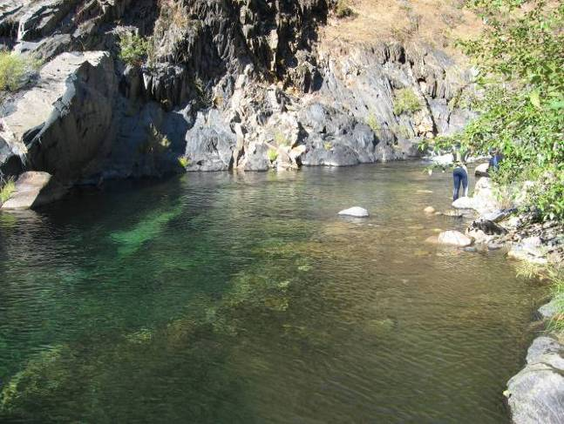 | 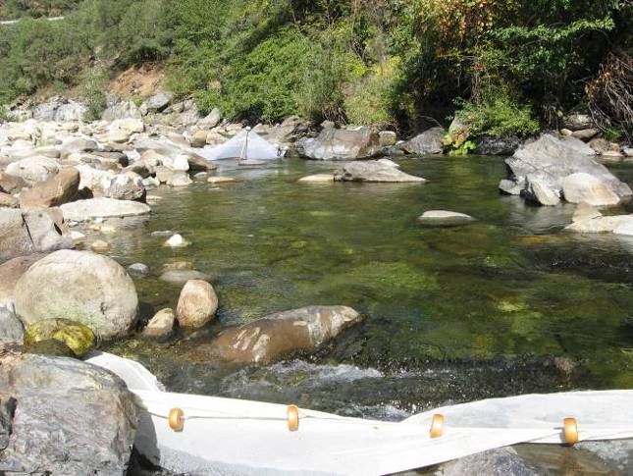
POOL | RUN
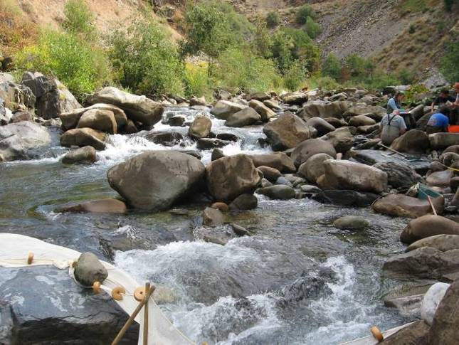
HGR

North Fork American River

NF18.4 (Bypass Reach)
2007 Sampled Mesohabitat Units
Unit Number | Unit Type¹ | Sampling Method² | Length (ft) | Width (ft) | Unit Area (ft²) | Mean Depth (ft) | Max Depth (ft) | % of Total Survey Length | % of Total Survey Area
1 | Pool | S | 480.0 | 12.0 | 5760.0 | 3.5 | 6.0 | 10.9% | 1.2%
2 | Pool | S | 585.0 | 270.0 | 157950.0 | 7.0 | 14.0 | 13.3% | 32.9%
3 | Pool | S | 309.0 | 75.0 | 23175.0 | 4.0 | 7.0 | 7.0% | 4.8%
4 | Pool | S | 345.0 | 96.0 | 33120.0 | 2.8 | 4.5 | 7.9% | 6.9%
5 | Pool | S | 750.0 | 50.0 | 37500.0 | 5.5 | 18.0 | 17.1% | 7.8%
Total |  |  | 2469.0 | -- | 257505.0 | -- | -- | 56.2% | 53.6%
Average |  |  | 493.8 | 100.6 | 51501.0 | 4.6 | 9.9 | -- | --
6 | Run | S | 504.0 | 186.0 | 93744.0 | 2.5 | 8.0 | 11.5% | 19.5%
7 | Run | S | 216.0 | 55.0 | 11880.0 | 1.8 | 3.6 | 4.9% | 2.5%
8 | Run | S | 1205.0 | 97.0 | 116885.0 | 1.2 | 3.1 | 27.4% | 24.4%
Total |  |  | 1925.0 | -- | 222509.0 | -- | -- | 43.8% | 46.4%
Average |  |  | 641.7 | 112.7 | 74169.7 | 1.8 | 4.9 | --
Grand Total |  |  | 4394.0 | -- | 480014.0 | -- | -- | 100.0% | 100.0%
¹LGR = Low Gradient Riffle; HGR = High Gradient Riffle
²S = Snorkeling

Photos of Representative Habitat Units:
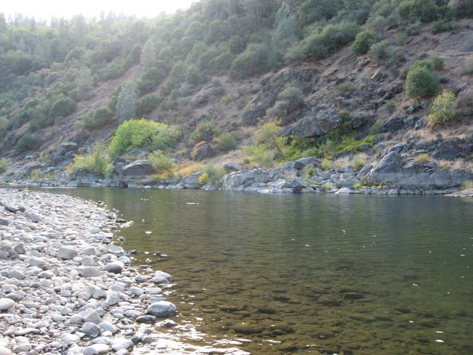 | 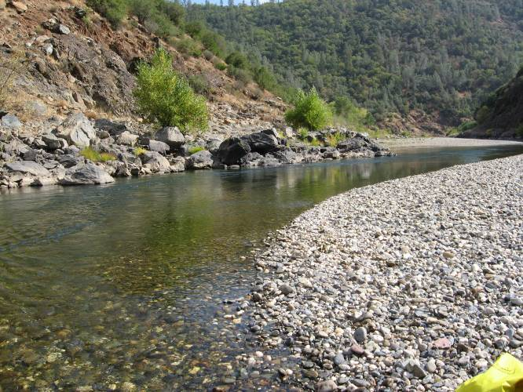
POOL | RUN

North Fork American River

NF31.3 (Comparison Reach)
2007 Sampled Mesohabitat Units
Unit Number | Unit Type¹ | Sampling Method² | Length (ft) | Width (ft) | Unit Area (ft²) | Mean Depth (ft) | Max Depth (ft) | % of Total Survey Length | % of Total Survey Area
1 | Pool | S | 630.0 | 90.0 | 56700.0 | 2.0 | 5.0 | 19.7% | 19.2%
2 | Pool | S | 537.0 | 111.0 | 59607.0 | 2.0 | 6.5 | 16.8% | 20.1%
3 | Pool | S | 1032.0 | 108.0 | 111456.0 | 4.0 | 11.0 | 32.3% | 37.7%
Total |  |  | 2199.0 | -- | 227763.0 | -- | -- | 68.8% | 77.0%
Average |  |  | 733.0 | 103.0 | 75921.0 | 2.7 | 7.5 | -- | --
4 | Run | S | 117.0 | 36.0 | 4212.0 | 1.0 | 2.0 | 3.7% | 1.4%
5 | Run | S | 237.0 | 102.0 | 24174.0 | 1.0 | 2.0 | 7.4% | 8.2%
6 | Run | S | 195.0 | 66.0 | 12870.0 | 0.6 | 1.2 | 6.1% | 4.4%
7 | Run | S | 447.0 | 60.0 | 26820.0 | 0.6 | 2.1 | 14.0% | 9.1%
Total |  |  | 996.0 | -- | 68076.0 | -- | -- | 31.2% | 23.0%
Average |  |  | 249.0 | 66.0 | 17019.0 | 0.8 | 1.8 | -- | --
Grand Total |  |  | 3195.0 | -- | 295839.0 | -- | -- | 100.0% | 100.0%
¹LGR = Low Gradient Riffle; HGR = High Gradient Riffle
²S = Snorkeling

Photos of Representative Habitat Units:
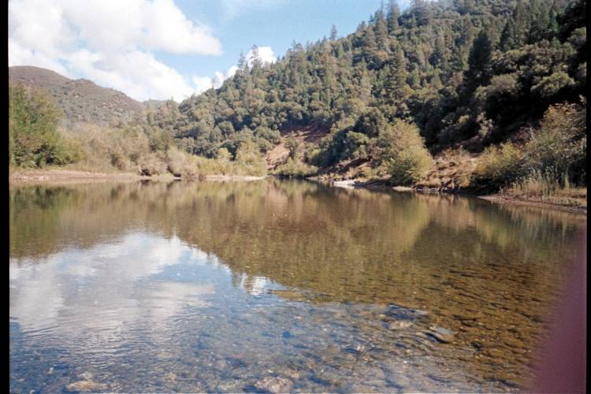 | 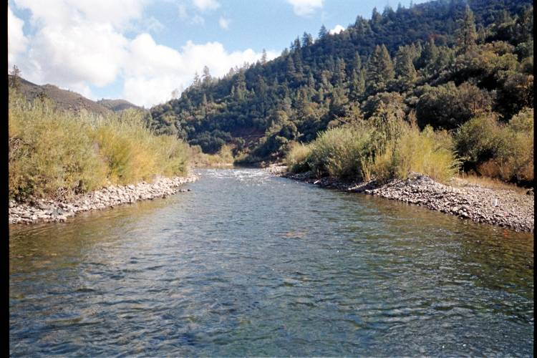
POOL | RUN

North Fork American River

NF53.7 (Comparison Reach)
2007 Sampled Mesohabitat Units
Unit Number | Unit Type¹ | Sampling Method² | Length (ft) | Width (ft) | Unit Area (ft²) | Mean Depth (ft) | Max Depth (ft) | % of Total Survey Length | % of Total Survey Area
1 | Pool | S | 573.0 | 93.0 | 53289.0 | 6.0 | 16.0 | 31.4% | 44.4%
2 | Pool | S | 405.0 | 72.0 | 29160.0 | 5.5 | 14.0 | 22.2% | 24.3%
3 | Pool | S | 85.5 | 18.0 | 1539.0 | 2.0 | 4.0 | 4.7% | 1.3%
4 | Pool | S | 429.0 | 61.5 | 26383.5 | 6.0 | 16.0 | 23.5% | 22.0%
Total |  |  | 1492.5 | -- | 110371.5 | -- | -- | 81.9% | 91.9%
Average |  |  | 373.1 | 61.1 | 27592.9 | -- | 12.5 | -- | --
5 | Run | E | 189.0 | 39.0 | 7371.0 | 1.2 | 2.0 | 10.4% | 6.1%
6 | Run | S | 93.0 | 17.0 | 1581.0 | 1.2 | 2.0 | 5.1% | 1.3%
Total |  |  | 282.0 | -- | 8952.0 | -- | -- | 15.5% | 7.5%
Average |  |  | 141.0 | 28.0 | 4476.0 | 1.2 | 2.0 | -- | --
7 | HGR | S | 48.0 | 15.0 | 720.0 | 1.3 | 1.7 | 2.6% | 0.6%
Total |  |  | 48.0 | -- | 720.0 | -- | -- | 2.6% | 0.6%
Grand Total |  |  | 1822.5 | -- | 120043.5 | -- | -- | 100.0% | 100.0%
¹LGR = Low Gradient Riffle; HGR = High Gradient Riffle
²S = Snorkeling; E = Electrofishing

2008 Sampled Mesohabitat Units
Unit Number | Unit Type¹ | Sampling Method² | Length (ft) | Width (ft) | Unit Area (ft²) | Mean Depth (ft) | Max Depth (ft) | % of Total Survey Length | % of Total Survey Area
1 | Pool | S | 573.0 | 93.0 | 53289.0 | 6.0 | 16.0 | 31.4% | 43.8%
2 | Pool | S | 405.0 | 72.0 | 29160.0 | 5.5 | 14.0 | 22.2% | 24.0%
3 | Pool | S | 85.5 | 18.0 | 1539.0 | 2.0 | 4.0 | 4.7% | 1.3%
4 | Pool | S | 429.0 | 61.5 | 26383.5 | 6.0 | 16.0 | 23.5% | 21.7%
Total |  |  | 1492.5 | -- | 110371.5 | -- | -- | 81.9% | 90.7%
Average |  |  | 373.1 | 61.1 | 27592.9 | 4.9 | 12.5 | -- | --
5 | Run | E | 189.0 | 48.0 | 9072.0 | 1.6 | 2.7 | 10.4% | 7.5%
6 | Run | S | 93.0 | 17.0 | 1581.0 | 1.2 | 2.2 | 5.1% | 1.3%
Total |  |  | 282.0 | -- | 10653.0 | -- | -- | 15.5% | 8.8%
Average |  |  | 141.0 | 32.5 | 5326.5 | 1.4 | 2.5 | -- | --
7 | HGR | S | 48.0 | 15.0 | 720.0 | 1.3 | 0.7 | 2.6% | 0.6%
Total |  |  | 48.0 | -- | 720.0 | -- | -- | 2.6% | 0.6%
Grand Total |  |  | 1822.5 | -- | 121744.5 | -- | -- | 100.0% | 100.0%
¹LGR = Low Gradient Riffle; HGR = High Gradient Riffle
²S = Snorkeling; E = Electrofishing

North Fork American River

NF53.7 (Comparison Reach)

Photos of Representative Habitat Units:
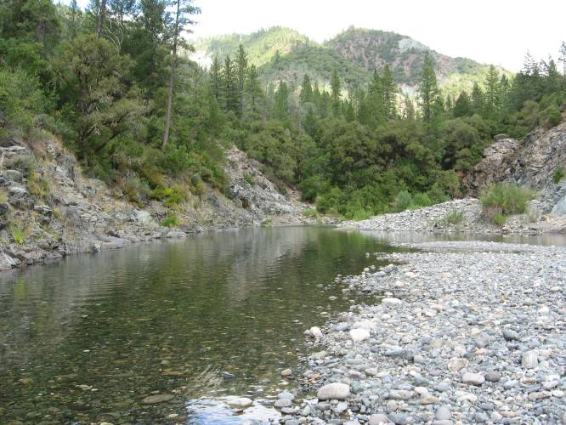 | 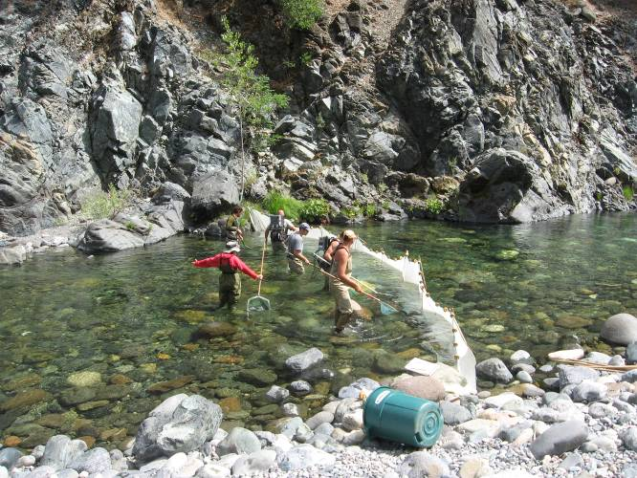
POOL | RUN
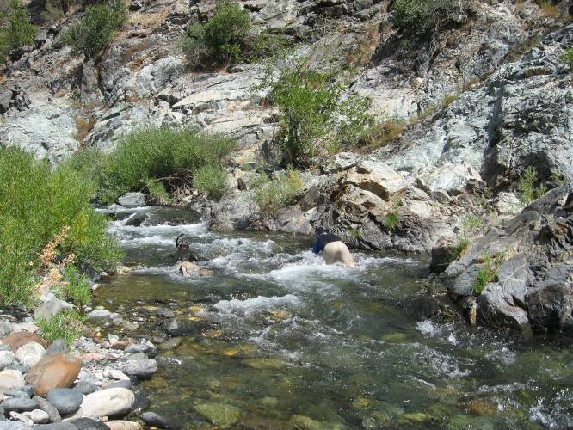
HGR

Representative Photos of Project - Reservoirs and Diversion Pools

Ralston Afterbay

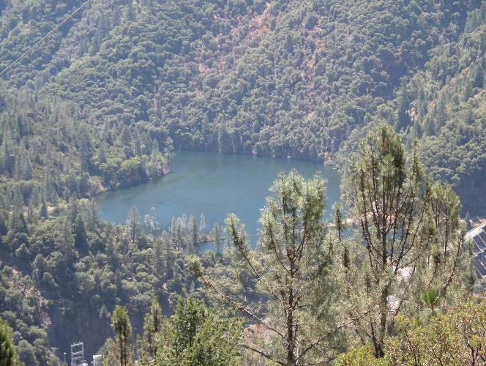 | 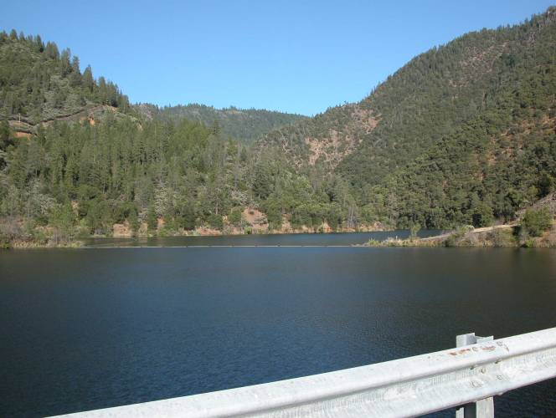

Middle Fork Interbay

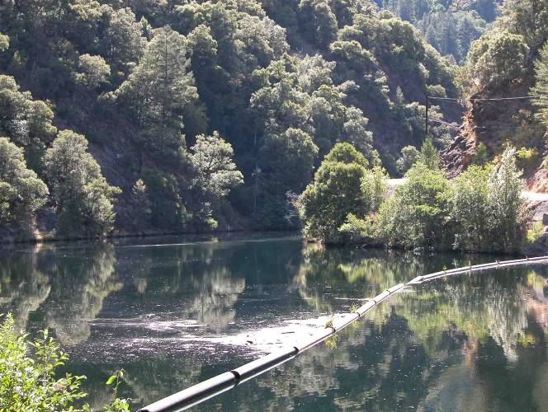

French Meadows Reservoir

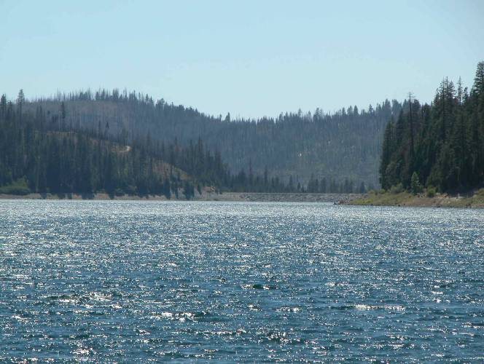 | 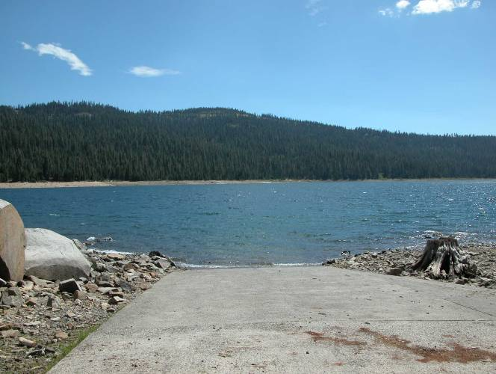

Hell Hole Reservoir

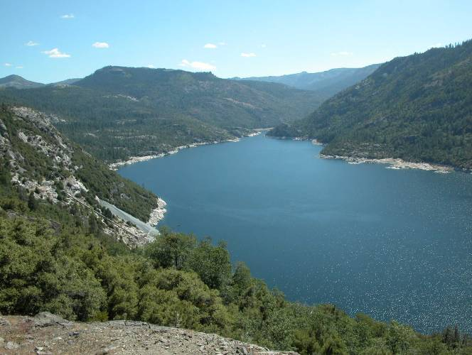 | 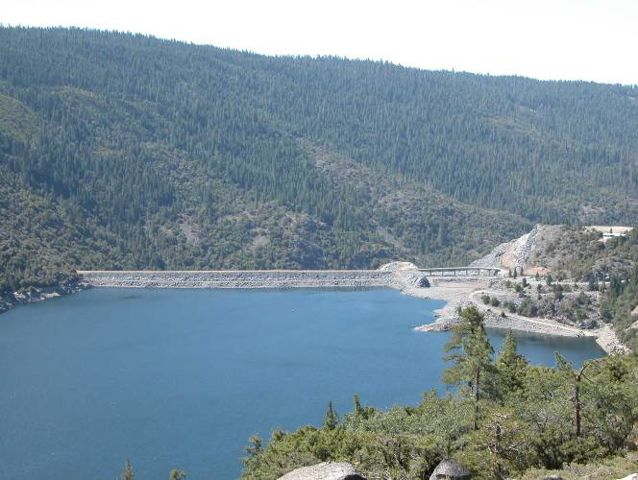

North Fork Long Canyon Creek Diversion Pool

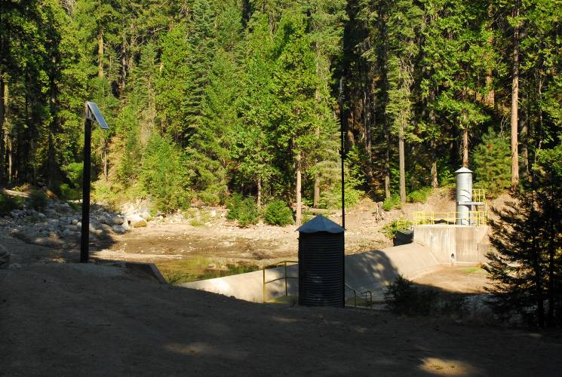

South Fork Long Canyon Creek Diversion Pool

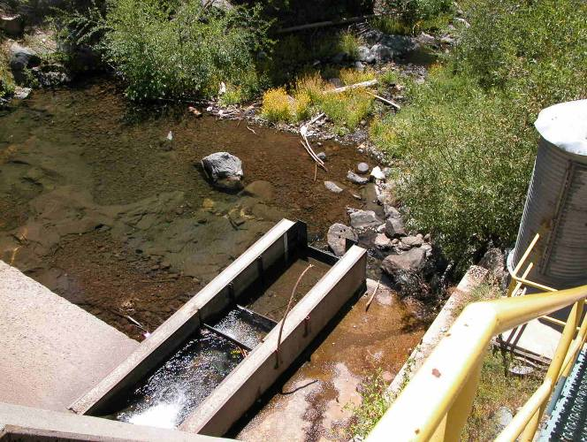

Duncan Creek Diversion Pool

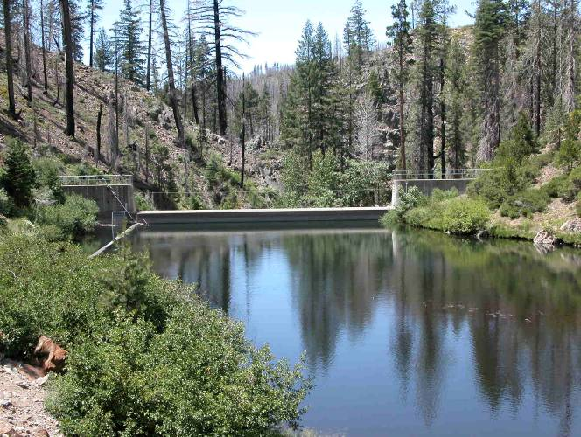

TABLES
Table A-1. Reach Mesohabitat Percentages.

Study River and Site ID |  | Rosgen Geomorphic Reach¹  (Type, Name) |  | Reachwide Mesohabitat Percentages by Length |  |  |  |  |  |  |  | Total
 |  |  |  | Pool |  | Run |  | High Gradient Riffle |  | Low Gradient Riffle |  | Total
Middle Fork American River Downstream of Ralston Afterbay
MF4.8 | F, MFAR-R1 |  | 59.5% |  | 30.0% |  | 2.7% |  | 7.9% |  | 100.0%
MF14.1 | F, MFAR-R3 |  | 55.2% |  | 29.2% |  | 4.6% |  | 11.0% |  | 100.0%
Middle Fork American River from Middle Fork Interbay to Ralston Afterbay
MF26.2 | Bc/F, MFAR-R4 |  | 43.3% |  | 28.6% |  | 21.2% |  | 6.9% |  | 100.0%
Middle Fork American River Upstream of Middle Fork Interbay
MF36.2 | Ba/Fb, MFAR-R5 |  | 60.3% |  | 16.6% |  | 18.0% |  | 5.1% |  | 100.0%
MF44.7 | Ba/Fb, MFAR-R5 |  | 60.3% |  | 16.6% |  | 18.0% |  | 5.1% |  | 100.0%
MF51.8 | B3 |  | NA² |  | NA² |  | NA² |  | NA² |  | NA²
Rubicon River
R3.5 | Bc/F, RUB-R1 |  | 49.0% |  | 27.7% |  | 11.6% |  | 11.7% |  | 100.0%
R20.9 | B/Fb, RUB-R2 |  | 46.2% |  | 24.7% |  | 25.2% |  | 3.9% |  | 100.0%
R25.7 | C, RUB-R3 |  | 43.4% |  | 24.9% |  | 13.2% |  | 18.5% |  | 100.0%
R36.2 | B3 |  | NA² |  | NA² |  | NA² |  | NA² |  | NA²
Long Canyon Creek
LC9.0 | F, LONG-R2 |  | 43.6% |  | 16.2% |  | 13.6% |  | 26.7% |  | 100.0%
North Fork Long Canyon Creek
NFLC1.9 | B, NFLONG-R1 |  | 43.0% |  | 15.1% |  | 24.2% |  | 17.7% |  | 100.0%
NFLC3.8 | B2-3 |  | NA² |  | NA² |  | NA² |  | NA² |  | NA²
South Fork Long Canyon Creek
SFLC2.3 | B, SFLONG-R1 |  | 40.3% |  | 27.7% |  | 15.2% |  | 16.8% |  | 100.0%
SFLC4.2 | B3 |  | NA² |  | NA² |  | NA² |  | NA² |  | NA²
Duncan Creek
D6.3 | B/F, DUN-R2 |  | 52.8% |  | 14.3% |  | 25.2% |  | 7.7% |  | 100.0%
D9.0 | B1-2 |  | NA² |  | NA² |  | NA² |  | NA² |  | NA²
North Fork of the Middle Fork American River
NFMF2.3 | F2-3/B2-3 |  | NA² |  | NA² |  | NA² |  | NA² |  | NA²
North Fork American River
NF18.4 | F |  | NA² |  | NA² |  | NA² |  | NA² |  | NA²
NF31.3 | F3-4 |  | NA² |  | NA² |  | NA² |  | NA² |  | NA²
NF53.7 | unknown |  | NA² |  | NA² |  | NA² |  | NA² |  | NA²
¹For Location of Geomorphic Reaches see Map AQ 2-1. Geomorphic reaches are identified in: Placer County Water Agency (PCWA). 2007. 2006 Physical Habitat Characterization Study Report. In PCWA’s Pre-Application Document (PAD) for the Middle Fork American River Project (FERC Project No. 2079), 2005/2006 Technical Study Plans and Reports, SD G (1 of 2).
²NA = Habitat percentages are unavailable for sites outside of the Project Study area.

Table A-2. August 2007 Water Temperature Summary.

Study Site | Water Temperature (ºF)¹
 | Avg | Max | Min
Middle Fork American River Downstream of Ralston Afterbay
MF4.8 | 61.8 | 67.3 | 57.7
MF14.1 | 57.8 | 61.1 | 54.4
Middle Fork American River from Middle Fork Interbay to Ralston Afterbay
MF26.2 | 67.5 | 72.7 | 62.4
Middle Fork American River Upstream of Middle Fork Interbay
MF36.2 | 64.9 | 70.3 | 59.8
MF44.7 | 56.5 | 60.5 | 51.8
MF51.8 | 63.3 | 73.8 | 51.9
Rubicon River
R3.5 | 71.1 | 77.2 | 66.1
R20.9 | 60.8 | 64.7 | 57.0
R25.7 | 55.7 | 60.1 | 51.3
R36.2 | 66.1 | 72.0 | 59.8
Long Canyon Creek
LC9.0 | 60.5 | 67.8 | 54.6
North Fork Long Canyon Creek
NFLC1.9 | 60.9 | 74.2 | 52.9
NFLC3.8 | 58.7 | 62.4 | 54.8
South Fork Long Canyon Creek
SFLC2.3 | 58.1 | 65.6 | 51.7
SFLC4.2 | 55.3 | 64.0 | 48.2
Duncan Creek
D6.3 | 66.2 | 73.2 | 62.3
D9.0 | 63.5 | 68.8 | 60.4
North Fork of the Middle Fork American River
NFMF2.3 | 70.0 | 76.4 | 64.4
North Fork American River
NF18.4 | 64.2 | 69.6 | 60.4
NF31.3 | 74.7 | 82.7 | 68.8
NF53.7 | --² | -- | --
¹See 2006 Water Temperature Study Report (PCWA 2007c) for details and location of temperature probes
²Temperature data was not available for site NF53.7

Table A-3a. 2007 Physical Habitat Characteristics of Potential Comparison Sampling Sites.

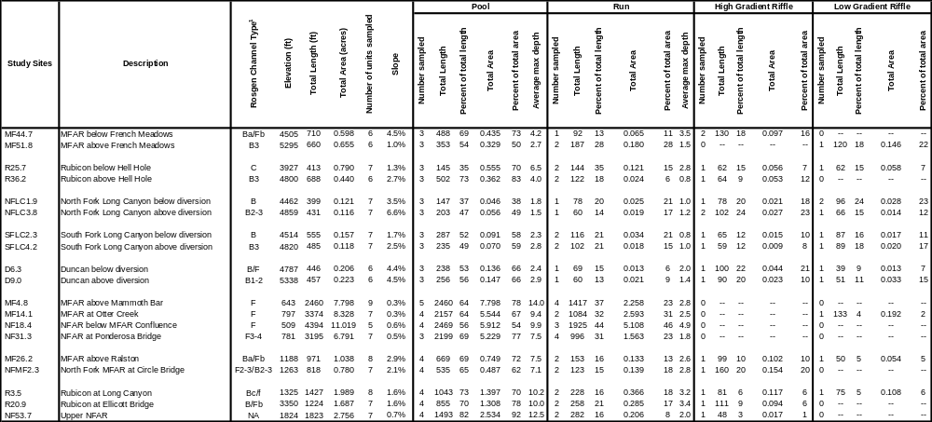
Table A-3b. 2008 Physical Habitat Characteristics of Potential Comparison Sampling Sites.

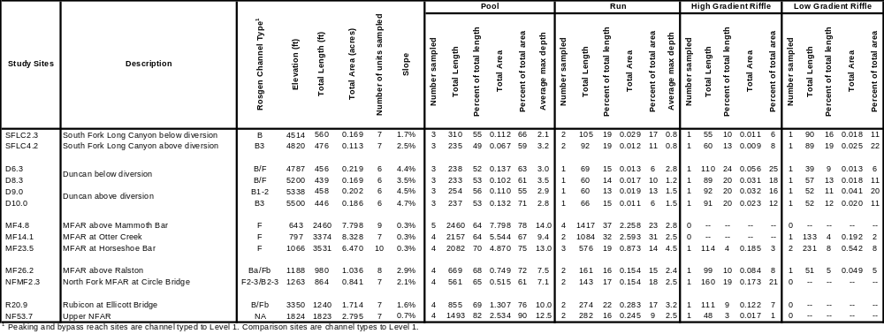

Table A-3c. 2009 Physical Habitat Characteristics of Potential Comparison Sampling Sites.

 |  |  |  |  |  |  |  | Pool |  |  |  |  |  | Run |  |  |  |  |  | High Gradient Riffle |  |  |  |  | Low Gradient Riffle
Study Sites | Description | Rosgen Channel Type¹ | Elevation (ft) | Total Length (ft) | Total Area (acres) | Number of Units Sampled | Slope | Number Sampled | Total Length | Percent of Total Length | Total Area | Percent of Total Area | Average Max Depth | Number Sampled | Total Length | Percent of Total Length | Total Area | Percent of Total Area | Average Max Depth | Number Sampled | Total Length | Percent of Total Length | Total area | Percent of Total Area | Number Sampled | Total Length | Percent of Total Length | Total Area | Percent of Total Area
SFLC2.3 | South Fork Long Canyon below diversion | B | 4514 | 562 | 0.171 | 7 | 1.7% | 3 | 284 | 51 | 0.102 | 60 | 2.4 | 2 | 100 | 18 | 0.024 | 14 | 0.8 | 1 | 72 | 13 | 0.013 | 8 | 1 | 106 | 19 | 0.032 | 19
SFLC3.0 | South Fork Long Canyon below diversion | B |  | 505 | 0.163 | 7 |  | 3 | 255 | 51 | 0.100 | 62 | 27 | 2 | 100 | 20 | 0.019 | 12 | 0.9 | 1 | 60 | 12 | 0.017 | 10 | 1 | 90 | 18 | 0.027 | 17
SFLC4.2 | South Fork Long Canyon above diversion | B3 | 4820 | 478 | 0.134 | 7 | 2.5% | 3 | 222 | 46 | 0.066 | 49 | 2.9 | 2 | 106 | 22 | 0.033 | 25 | 1.0 | 1 | 60 | 13 | 0.006 | 5 | 1 | 90 | 19 | 0.029 | 22
SFLC5.2 | South Fork Long Canyon above diversion | B3 |  | 435 | 0.100 | 7 |  | 3 | 181 | 42 | 0.051 | 51 | 1.9 | 2 | 99 | 23 | 0.024 | 24 | 0.8 | 1 | 65 | 15 | 0.012 | 12 | 1 | 90 | 21 | 0.012 | 12
¹Peaking and bypass reach sites are channel typed to Level 1. Comparison sites are channel types to Level 1.

